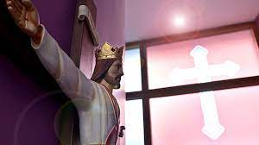

Chaplaincy: Today and the Future

Our Mission Statement:
‘Inspiring hearts and minds with Christ at the Centre of all we say and do.’
Our Chaplaincy Team action plan for the 2023/24 school year is to:
- Get more members to join the Chaplaincy.
- To Raise money for the Black Country Foodbank.
- Donate more to Saint Chad’s Sanctuary- use them as one of our charities.
- Spreading chaplaincy life in school by talking to more students.
- Helping to educate people about Catholicism.
- Help charities like CAFOD to earn money and give to different countries and those in need.
- Involve the chaplaincy and liturgy team in prayer and liturgy more in tutor.
- Host more masses throughout the school year.
- Be able to spread the word of God by speaking to others.
- Offer spiritual care to those who need it.
- The ability to be able to improve someone's life- those who have little.
Some important dates that are upcoming
- The Birth of Christ (Christmas 2023)
- The Epiphany of the Lord (6th January 2024)
- The Baptism of Christ (2nd Sunday of the Epiphany 2024)
- St. John Bosco (31st January 2024)
- The Presentation of Christ in the Temple (2nd February 2024)77-
Our Lay Chaplain:

Our new Lay Chaplain Miss Mudenda joined us in September 2023.

“My name is Miss Mudenda, and I am delighted to join Bishop Milner, having received such a warm welcome already! Being part of the already brilliant Catholic Life is an honour and I look forward to getting to work with both staff and students.’

On Friday 29th September, our chaplaincy team went to St. Chad’s Cathedral and was able to meet the archbishop! In the chaplaincy team, we take many trips across the West Midlands. One of these examples is when we visited a neighbouring school who are also a part of the Saint John Bosco Academy which was the school of Stuart Bathurst.
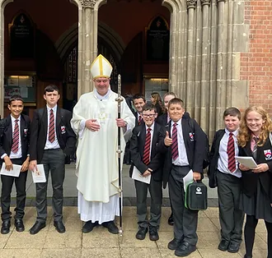

Our College Prayer:

Dear God,
On our journey to be who you call us to be:
Give us the strength and resilience, shown by St Peter, to never give up.
Help us to inspire others along the way by keeping your son, Jesus Christ, at the centre of all that we say and do.
Amen
Bishop Milner: Pray for us
St Peter: Pray for us

Written by: Ava Totney, Amelia Biegata, Kai Slater Lilia-Mae Jones and Miller Whittaker.

