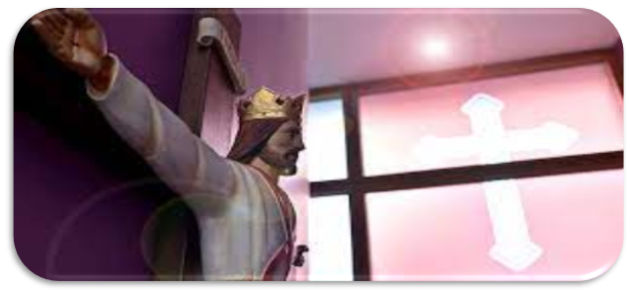

Chaplaincy Newsletter: Today and the Future

Autumn 2

Season: Advent

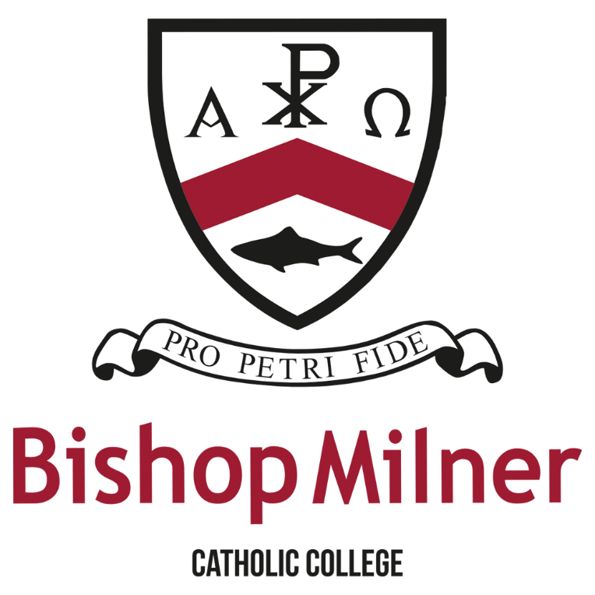

Our Mission Statement:
‘Inspiring hearts and minds with Christ at the Centre of all we say and do.’

Our Chaplaincy Team action plan for the 2023/24 school year is to:
- Get more members for chaplaincy.
- Raise money for Dudley Foodbank.
- Spreading chaplaincy life in school.
- Helping to educate people about Catholicism.
- Help charities like CAFOD to earn money and give to different countries.
- Involve prayer and liturgy more in tutor.
- Host more masses.
- Be able to spread the word of God.
- Offer spiritual care in the clinical setting.
- The ability to be able to improve someone's life.
- Forming life-giving relationships with individual

Some important dates that are upcoming:
- Senior Citizen Party (8th December 2023)
- Immaculate Conception of Mary (8th December 2023)
- The Birth of Christ (Christmas Mass 2023)
- The Epiphany of the Lord (6th January 2024)
- The Baptism of Christ (2nd Sunday of the Epiphany 2024)
- St. John Bosco (31st January 2024)
- The Presentation of Christ in the Temple (2nd February 2024)

Our Lay Chaplain:

Our new Lay Chaplain Miss Mudenda joined us in September 2023.

’My name is Miss Mudenda, and I am delighted to join Bishop Milner, having received such a warm welcome already! Being part of the already brilliant Catholic Life is an honour and I have had the amazing opportunity to get stuck in and get to know everybody, have several Chapel sessions based around themes such as Sacraments, the Season of Creation and Advent and work with Year groups for Masses.’’

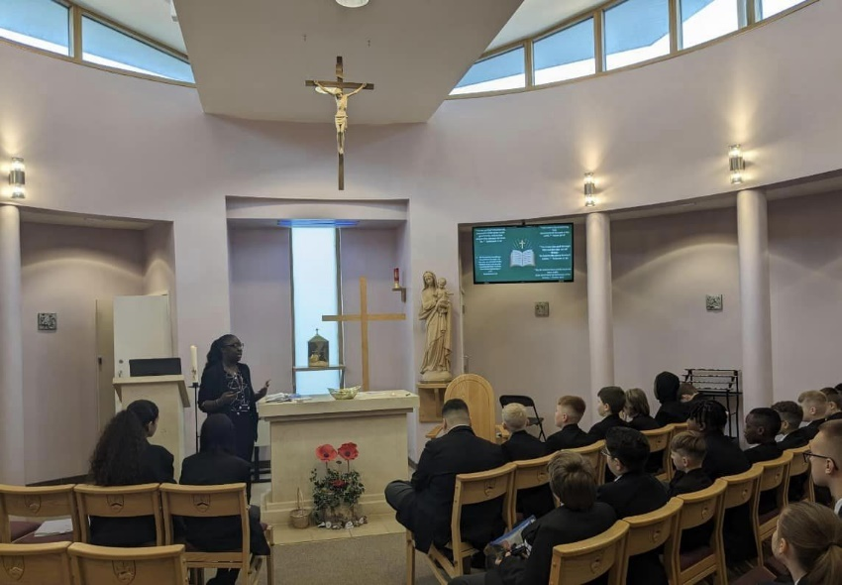

Chaplaincy Experiences:

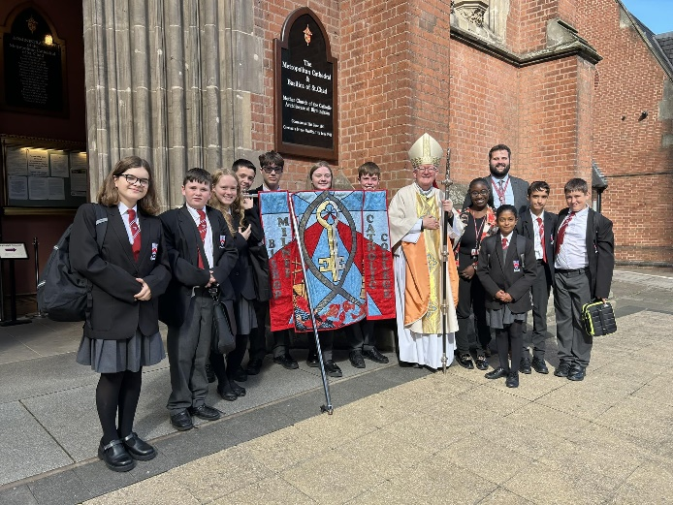
On Friday 29th September, our Chaplaincy team along with our Lay Chaplain and PICCL went to St. Chad’s Cathedral for a Chaplaincy Commissioning Mass and we were able to meet the Archbishop of Birmingham, Bernard Longley! We also got to meet and chat to other young people from Chaplaincy teams across the Archdiocese!
Chaplaincy Testimonies: Geona J (Year 7)

‘’I first started Altar Serving in 2021, being inspired by my older sister. As I got older, I thought the feeling of serving would bring me closer to God. When I first joined Bishop Milner, 3 days into year 7 we had a Catholic Life drop down day where we learnt about who Bishop Milner is, what the school badge means and represents. Before I knew it, I was serving alongside Fr. Paul in front of my whole Year Group for Mass at the end of the day! After that, I served at other Year Group Masses for years 8, 9 and 10. I even got to serve for the Archbishop of Birmingham for the MAC 10th Anniversary Mass held for all the schools and over 400 people! It was a huge day for me and I was so nervous but was grateful for the opportunity. I look forward to working more in the Liturgy Team and helping out for school events.’’
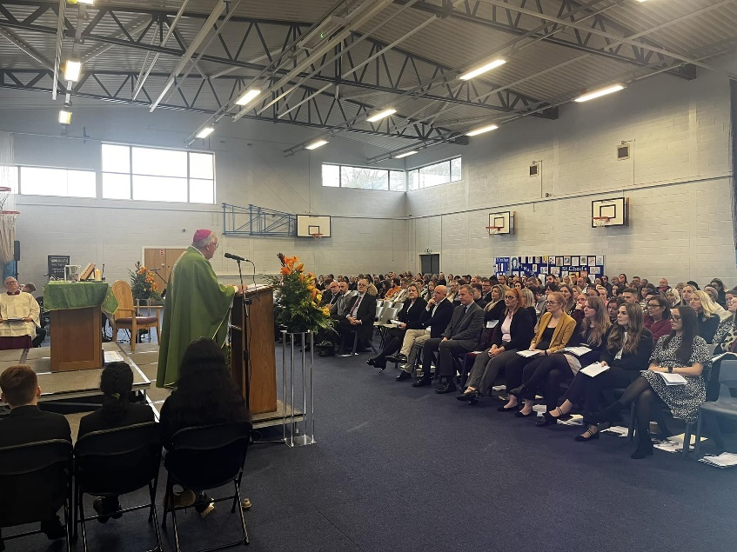

Chaplaincy Testimonies: Chudi A (Year 7)

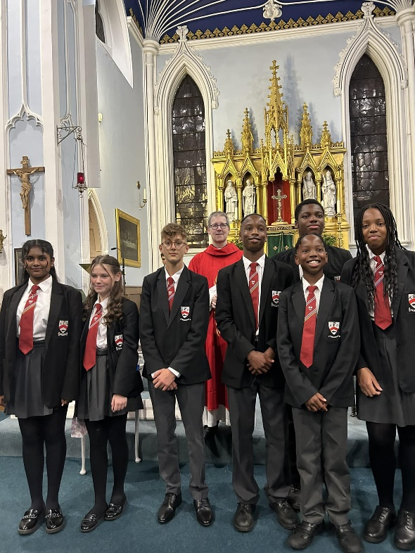
‘’Last term, I had the chance to do my Sacraments at Bishop Milner after joining in Year 7. I had to prepare to do my First Holy Communion, Confession and Confirmation. The preparation was a little bit nerve-wracking because I did not want to mess up in front of everyone. I was also excited as I had been waiting a long time and had always wanted to know what the bread tasted like! I worked with the Lay Chaplain for the preparation, doing sessions in the Chapel, learning about each Sacrament and working on choosing my Saint’s name. I chose Saint Sebastian, the patron saint of athletes as I love playing sports and he inspired me because he died for what he believed in. I also spoke to our School Priest Chaplain, Fr. Paul who helped me do my first Confession. On the day of the Sacraments, I was extremely nervous and was worried when I didn’t have a sponsor but thankfully, my auntie stepped forward. I was very happy to receive my first Sacraments and also had my brother and sister with me too.’’

Our college Prayer:

Dear God,
​
On our journey to be who you call us to be:
Give us the strength and resilience, shown by St Peter, to never give up.
Help us to inspire others along the way by keeping your son, Jesus Christ, at the centre of all that we say and do.
​
Amen
​
Bishop Milner: Pray for us
St Peter: Pray for us

Dear God,
On our journey to be who you call us to be:
Give us the strength and resilience, shown by St Peter, to never give up.
Help us to inspire others along the way by keeping your son, Jesus Christ, at the centre of all that we say and do.
Written by: M. Whittaker, K. Slater, T. Gilroy, L-M. Jones, Geona J, Chudi A

Last Updated: 07/12/2023

