
Careers support and information

Event Title: In-Comm Training Services OPEN DAYS
Date/Time: Tuesday 28th July – Aldridge & Thursday 30th July – Telford (9:30am - 12:30pm)
Location: See on the links below

In-Comm Training Services Open Days are coming up soon:
- Tuesday 28th July – Aldridge
- Thursday 30th July – Telford
- Drop in anytime between 9:30am and 12:30pm Come along to:
Explore their Engineering Apprenticeships and the skills you can gain and speak with the Apprentice Ambassadors about their experiences. Have a chat with the recruitment team, who can even arrange an initial interview on the day, providing you have already or will meet the academic criteria required(GCSE student).
See further information below:
👉 Open Day - Aldridge 👉 Telford – Open Day - Telford
Parents are welcome too and if you have any questions, please let us know.

Event Title: Learning Development Training – Open Days
Date/Time: See below
Location: See below

Learning Development Training are delighted to announce the second year of admissions for LD6, their post-16 provision, designed to support young people with Education, Health and Care Plans (EHCPs).
Admissions are now open for September 2026 entry, and they would like to warmly invite parents, carers, and students to attend our upcoming Open Days.
Location:
LD Training Services Dudley Campus, 1St Floor, Trafalgar House, 47-49 King St, Dudley, England, DY2 8PS (Map for parking is attached to email)
Open Day/Evening Dates & Times:
- Saturday 13th June 2026 at 10:00am – 2:00pm
- Friday 10th July 2026 at 10:00am – 2:00pm

Please find the link below to confirm your attendance. Please can these be completed by Thursday 11th June 2026.
Parent/Carers – LD6 Open Days May-July 2026 - Parents/Carers – Fill in form or you can scan the following QR link:
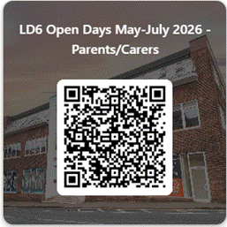
For further information please contact:
SEN Courses in Dudley | LD6 Supported Internships & Pathways
📧outreach@ldtraining.ac.uk
📞 01384 989 644 and ask for a member of the Outreach Team

