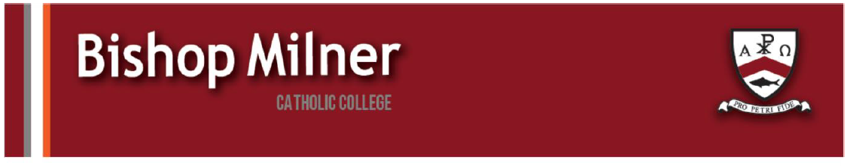
Careers support and information
Please see below for information regarding careers and local labour market information.
www.talkingfutures.org.uk
Talking Futures helps parents understand the range of education, training and career options available to your children, including apprenticeships, T Levels and university routes. It provides practical advice, conversation starters and activities to help you have positive, informed conversations about future choices. There is a link on the college website in the careers section.
Elevate – study skills
Elevate are offering sessions to support your child with their study skills and preparation for exams. For more information see the attached flyer.
Your Home, Your Safety:
West Midlands Residents are invited to Fire Safety and Building Remediation Event.
West Midlands residents living in buildings 11 metres or taller that are affected by unsafe cladding or fire safety concerns are invited to attend Your Home, Your Safety, a free community engagement event taking place on:
Monday 19 October
5:30pm to 7:30pm
West Midlands Fire Service Headquarters
99 Vauxhall Road, Nechells, Birmingham, B7 4HW
This is your opportunity to
- Ask questions about building safety and remediation
- Share your experiences and concerns
- Speak directly with the organisations responsible for fire safety and making buildings safe
- Find out more about ongoing work to accelerate remediation across the region

