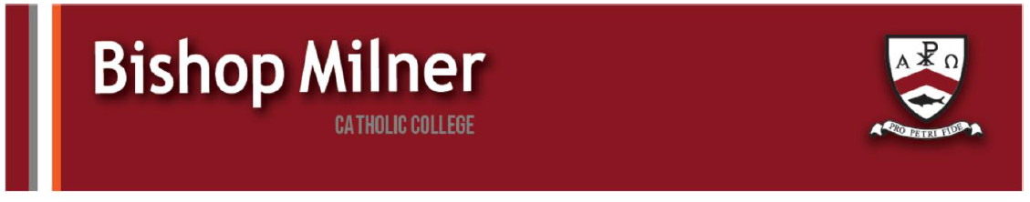
Careers support and information
- A reminder that you can access the parental support series for Elevate Education Series. The next session is on improving the memory skills of your child. See attachment for more details.

- Careers and workshops at the BBC. Please see the attached information regarding the BBC offering support, workshops and advice on careers and information.

BBC - From journalism, storytelling, production, or simply to learn more about the industry, BBC Academy Live presents BBC Verify on Tour a new series of free online sessions that are designed to inspire your students interested in the media. We’ve got the production teams behind the TV shows Tommy: The Good. The Bad. The Fury and Sunderland 'Til I Die’ giving exclusive behind the scenes insights that you won’t hear anywhere else. Plus, careers talks with people who all have a different journey into the industry sharing their tips; and sessions on how to improve media literacy with BBC Journalists in this new era of AI and disinformation. The first takes place on Friday 14th November, live from the University of Sunderland. Then we're at the University of Lancashire on Wednesday 3rd December.

- PJD TRAINING ACADEMY - BASIC CONSTRUCTION SEND COURSES
PJD Training Academy offers a 6-week practical-based level 1 Award in Basic Construction Skills designed to introduce young people to the work of construction through a supportive and flexible learning approach.

The course is ideal for SEND learners who thrive in practical, hands-on environments and students aged 14+ interested in practical construction pathways. Learners will develop confidence and essential trade skills while gaining an accredited qualification that supports future progression into construction apprenticeships, or further vocational training.
- Practical, workshop-based delivery - one day per week, flexible delivery.
- Delivered by a qualified SEND teacher with experience inclusive and differentiated learning.
- Provision tailored for SEND learners with a focus on inclusion and engagement.
Further information and contact details for any questions can be found on the attached SEND flyer.

- LEAF
Leaf is a highly selective online program that prepares talented teenagers to make a positive impact at university and in their future careers. Our January-February cohort brings together exceptional 15–19-year-olds to explore how they can apply their academic talents to solving global challenges and prepare for meaningful study at top universities.
Choose from:
- The Mathematics of Morality — how quantitative reasoning can shape ethical decisions
- Dilemmas and Dangers in AI — steering powerful technology toward good
- Biology for a Better Tomorrow — science in service of human flourishing and the natural world
- History to Shape History — lessons from economics, law, and the past to guide humanity’s future
Participants gain:
- Live seminars with Oxford and Cambridge student mentors
- Curated weekly curriculum, activities, and projects
- Access to a global community of top students
- College and job search prep. and advice
- Opportunities for further mentorship, scholarships, and selective fellowships!
Leaf courses operate on an accessible sliding tuition scale, including free access if needed. Applications for Winter 2026 close December 22nd
Learn more at leaf.courses or apply now!

- NATIONAL HIGHWAYS – TOMORROW’S ENGINEERS WEEK
For Tomorrow’s Engineers Week (w/c 10th November), the Education Engagement team at National Highways have created some case studies with the theme Power Up Your Passion.
See attached for case studies.

