
Bishop Milner Catholic College

Relationship, Sex and Health Education (RSHE) Policy

‘Inspiring hearts and minds with Christ at the centre of all we say and do’

Review Date: September 2025
Agreed by Governing body (Date):

Aims
The aims of RSHE education at Bishop Milner Catholic College are:
- first and foremost to know that they are loved and made in the image of God
- to enable our students to better understand the nature of relationships
- to help students develop feelings of self-respect, confidence and empathy
- to create a positive culture around issues of sexuality and relationships
- to enable students to understand the importance of stable loving relationships, including marriage, for the bringing up of children
- to prepare students for the changes that occur to their bodies, minds and emotions as a consequence of growth from childhood to adulthood
- to know about the risks of being online and how to stay safe from exploitation
- to support all young people for life in modern Britain.

Objectives

To develop the following attitudes and virtues:
- reverence for the gift of human sexuality and fertility
- respect for the dignity of every human being – in their own person and in the person of others
- joy in the goodness of the created world and their own bodily natures
- responsibility for their own actions and a recognition of the impact of these on others
- recognising and valuing their own sexual identity and that of others
- celebrating the gift of life-long, self-giving love
- recognising the importance of marriage and family life
- fidelity in relationships.

To develop the following personal and social skills:
- making sound judgements and good choices which have integrity, and which are respectful of the individual’s commitments
- loving and being loved, and the ability to form friendships and loving, stable relationships free from exploitation, abuse and bullying
- managing emotions within relationships, and when relationships break down, with confidence, sensitivity and dignity
- managing conflict positively, recognising the value of difference
- cultivating humility, mercy and compassion, learning to forgive and be forgiven
- developing self-esteem and confidence, demonstrating self-respect and empathy for others
- building resilience and the ability to resist unwanted pressures, recognising the influence and impact of the media, internet and peer groups and so developing the ability to assess pressures and respond appropriately

- being patient, delaying gratification and learning to recognise the appropriate stages in the development of relationships, and how to love chastely
- assessing risks and managing behaviours in order to minimise the risk to health and personal integrity.

To know and understand:
- the Church’s teaching on relationships and the nature and meaning of sexual love
- the Church’s teaching on marriage and the importance of marriage and family life
- the centrality and importance of virtue in guiding human living and loving
- the physical and psychological changes that accompany puberty
- the facts about human reproduction, how love is expressed sexually and how sexual love plays an essential and sacred role in procreation
- how to manage fertility in a way which is compatible with their stage of life, their own values and commitments, including an understanding of the difference between natural family planning and artificial contraception
- how to keep themselves safe from sexually transmitted infections and how to avoid unintended pregnancy, including where to go for advice.

Statutory requirements
As a secondary academy school, we must provide RSHE to all pupils as per section 34 of the Children and Social Work Act 2017.
This document ensures that Bishop Milner Catholic College follows and is in the process if implementing the guidance issued in the Relationships and Sex Education (RSE) and Health Education 2025 issued by the Department for Education.
In teaching RSHE, we are required by our funding agreements to have regard to guidance issued by the secretary of state as outlined in Section 403 of the Education Act 1996.
This policy is also informed by the Keeping Children Safe in Education Guidance 2025.
At Bishop Milner Catholic College, we teach RSHE as set out in this policy.

Policy Development
This policy has been developed in consultation with staff, pupils and parents. The consultation and policy development process involved the following steps:
- Review – gathering the voice of staff, students and parents

- Parent/stakeholder consultation – parents and any interested parties were invited to read about the policy and make recommendations.

- Pupil consultation – we investigated what exactly pupils want from their RSHE.

- Ratification – once amendments were made, the policy was shared with governors and ratified.

What is effective Relationship & Sex Education
It is lifelong learning about physical, moral and emotional development. It is about the understanding of the importance of a stable and loving relationship. It is also about the teaching of sex, sexuality, and sexual health as well as preparing students at school for opportunities, responsibilities and experiences of later life. It is not about the promotion of sexual orientation or sexual activity. Our curriculum is also designed to support children growing up in an increasingly complex and digital world. Whilst the internet is an overwhelmingly positive development in our lives, it does present significant challenges, particularly for young people. The dominance of social media, the prevalence of cyberbullying and the risk that children learn about relationships from untrustworthy sources – we aim to support children to make the right decisions and keep themselves safe and happy. The content and delivery of RSHE at College will be conducted in an age appropriate way.

Values
Each pupil is entitled to social and moral education that includes issues relating to personal relationship, sex sexuality and procreation. Consistent with Catholic teaching that sex and sexuality is a gift from God and should be valued and as with all relationships based on mutual respect and love which wills the others good in all things: ‘To love is to will the good of the other’ (St Thomas Aquinas)
As a faith school we endeavor to explore appropriate and safe connections with others, including friendships, relationships, and sex education. Not only this; we think that it is vital that students across all Key Stages can have the opportunity to evaluate the models of friendship and family in the modern world, as well as the integral principles of tolerance and diversity reflected in our multi-cultural community. We acknowledge that “there will be a range of opinions regarding RSE. The starting principle when teaching each of these must be that the applicable law should be taught in a factual way so that pupils are clear on their rights and responsibilities as citizens.’ (Department for Education Statutory Guidance RSE and Health Education page 1)
As a Catholic school our teaching is also reflective of the moral teachings of the Church and the gospels. We will make it clear what is the moral teaching of our specific religious tradition and what is legal under British law. Pupils will be given opportunity to explore and express different perspectives on moral issues relating to sex and relationships.

Personal and Social Skills
RSE encourages students to manage emotions and relationships confidently and sensitively whilst developing self-respect and empathy for others. Students are taught to make choices based on an understanding of difference, with an absence of prejudice and learning how to recognise and avoid exploitation and abuse. It also provides opportunities to develop communication skills and assertiveness within a range of different situations.

Knowledge and Understanding
RSE focuses on understanding physical development at appropriate stages. The students will explore; human sexuality, reproduction, sexual health, emotions and relationships. Students will also be provided with information on contraception and the range of local and national sexual health advice support services. Students will look at the reasons for delaying sexual

activity, the benefits to be gained from such delay and the avoidance of unplanned pregnancy. This will provide an objective and balanced view of sexual matters, correcting any misconceptions and misinformation students may have gained.

Delivery of RSE at Bishop Milner Catholic College

Balanced and Integrated
We will ensure that RSE is sensitive to the different needs of individual pupils and is taught in a way that allows access to those pupils at different stages of cognitive and emotional development. Since a Catholic school is committed to the education of the whole person, teaching on relationships and sexuality needs to be reflected in each relevant part of the curriculum. Whilst, for example, some aspects of RSE will be more appropriately explored in science lessons and some more appropriately explored in RE lessons, each should be informed by the other.
Each discipline should speak with consistency about the meaning of human love and the virtues that are enshrined in the Church’s teaching on human love. The teachings of the Catholic Church will be made explicit but whilst also respecting that in a diverse society other views are espoused by different sections of society and our own pupils. This foundation is echoed in the government documentation. “Effective RSE does not encourage early sexual experimentation. It should teach young people to understand human sexuality and to respect themselves and others. It enables young people to mature, build their confidence and self- esteem and understand the reasons for delaying sexual activity.” (Department for Education Statutory Guidance RSE and Health Education page 1)

How is relationship and sex education taught
The government requirements in terms of curriculum will be met across subject areas but primarily in RE, Science and Personal Development lessons, taught in the tutor time SAINT curriculum Since a Catholic school is committed to the education of the whole person, teaching on relationships and sexuality needs to be reflected in each relevant part of the curriculum.
The RE department will deliver those elements of the curriculum that are best taught and explored in RE lessons, the teaching of the Catholic Church will be explained, other views will be examined and discussed. The RE Department and Personal Development curriculum will utilise the resources from the Ten-Ten programme that have been authorised by the Archdiocese of Birmingham
In lessons pupils with explore how humans are:
Created and loved by God (this explores the individual) The Christian imperative to love self, made in the image and likeness of God, shows an understanding of the importance of valuing and understanding oneself as the basis for personal relationships.
Created to love others (this explores an individual’s relationships with others) God is love. We are created out of love and for love. The command to love is the basis of all Christian morality.

Created to live in community – local, national & global (this explores the individual’s relationships with the wider world) Human beings are relational by nature and live in the wider community. Through our exchange with others, our mutual service and through dialogue, we attempt to proclaim and extend the Kingdom of God for the good of individuals and the good of society.
Whilst promoting Catholic virtues, schools should ensure that children and young people are offered a broad and balanced RSE programme which provides them with clear factual, scientific information when relevant and meets the statutory requirements placed on schools.
The leads in PSHE, RE, and Science, and where appropriate other subjects, will ensure that what is taught fulfils the government requirements for secondary schools. RSE focuses on giving young people the information they need to help them develop healthy, nurturing relationships of all kinds including:
- Families
- Respectful relationships, including friendships
- Online and media
- Being safe
- Sexual relationships and sexual health
- The Law
The College recognises the need to create a supportive and secure atmosphere where students can develop the confidence needed to talk, listen and think about relationships and sex education. In order to do this, teachers will:
- Establish ground rules with students
- Emphasise the importance of mutual respect
- Encourage reflection
- Make students aware of the relevant persons to approach in the College. For more information about our RSE curriculum, see Appendix 1.
These areas of learning are taught within the context of family life taking care to ensure that there is no stigmatisation of children based on their home circumstances. Families can include single parent families, LGBT parents, families headed by grandparents, adoptive parents, foster parents/carers amongst other structures along with reflecting sensitively that some children may have a different structure of support around them, for example: they may be young carers.
We understand that teaching RSE in a secondary school should build on the learning at primary school. Through our network of feeder and Trust primary schools we work together to establish a benchmark for RSE provision to ensure that this learning will be built on developmentally.
Staff that deliver RSE at the College will be provided with CPD to ensure that they are skilled in their delivery.

Specialist Support
The College also recognises that some aspects of RSE must be taught by specialists. From time to time the College will invite professional health experts in to deliver issues relating to RSE.
These will be asked to conform to the following:
    - Visitors contributing to RSE will do so at the invitation of the College and will be qualified to make an appropriate contribution
    - Visitors must agree with the aims of the College in delivering its policy on RSE
    - When in class visitors will be supervised by a teacher who will be present at all times
    - Visitors will follow the College’s Safeguarding procedures if a disclosure occurs within
the classroom setting
    - Visitors will know and understand where their contribution fits into the College’s
programme for RSE and Citizenship

Dealing with sensitive issues
All teachers are given training on handling controversial topics, are made clear about confidentiality boundaries and know where/who to refer students to for confidential advice and support.
RSE is part of the College’s provision for Spiritual, Moral, Social and Cultural development. The following are protocols for discussion-based lessons with students:
- No one (teacher or student) will have to answer a personal question
- No one will be forced to take part in a discussion
- Meanings of words will be explained in a sensible and factual way
- Teachers may use their discretion in responding to questions and may say that the appropriate person to answer that question is the parent/carer
- It is expected that teachers’ personal beliefs and attitudes will not influence their teaching
of RSE
- If at any point a disclosure is made by a student it is the responsibility of the member of staff to follow the schools’ safeguarding policy and notify the College’s Designated Safeguarding Lead or Deputy DSL. Staff must also register any concerns for a student on CPOMs before notifying the Safeguarding Lead or Deputy DSL.

For further information on how we keep our students safe consult our Safeguarding Policy
via the College’s website.

Parental rights
We endeavour to work in partnership with parents, to provide children and young people with a relationship and sex education which is compatible with their physical, cognitive, psychological, and spiritual maturity, and rooted in a Catholic vision of education.

RSE is part of all students’ education and it is hoped that all will participate. Some parts of RSE are compulsory – these are part of the National Curriculum for Science. Parents have the right to withdraw their children from the [non-statutory/non-science] components of sex education within RSE up to and until 3 terms before the child turns 16. After this point, if the child wishes to receive sex education rather than being withdrawn, the school will arrange this.
Requests for withdrawal should be put in writing using the form found in Appendix 3 of this policy and addressed to the Head of School (Mrs Foster). A copy of withdrawal requests will be placed in the pupil’s educational record. The Head of School will discuss the request with parents and take appropriate action. When the Head of school receives such a letter they will invite the parents or carers to a meeting, at which the Head of School will explain clearly what the College’s policy is and seek to accommodate the wishes and/or concerns of the parents/carers. If that is not possible the pupil will be withdrawn from RSE and placed in another class where suitable work and supervision will be provided.

Roles and Responsibilities

The Local Governing Body
The Local Governing Body will approve the RSE policy, and hold the Head of School to account for its implementation

7.2 The Head of School
The Head of school is responsible for ensuring that RSE is taught consistently across the school, and for managing requests to withdraw students from [non-statutory/non-science] components of RSE (see section 6).

Staff
Staff are responsible for:
    - Delivering RSE in a sensitive way
    - Modelling positive attitudes to RSE
    - Responding to the needs of individual students
    - Responding appropriately to students whose parents wish them to be withdrawn from the [non-statutory/non-science] components of RSE
    - Staff do not have the right to opt out of teaching RSE. Staff who have concerns about teaching RSE are encouraged to discuss this with the Head of School

7.3 Students
Students are expected to engage fully in RSE and, when discussing issues related to RSE, treat others with respect and sensitivity. SEND students will be provided with support and differentiated resources as appropriate which will ensure RSE is accessible to them

Procedure for Monitoring and Evaluating RSE
The policy and its implementation will be reviewed every 12 months. The College will appoint an RSE link governor. The policy will be monitored by the Assistant Principal for Catholic Life and Personal Development, Mr Baker who will:
- Ensure that RSE is covered in the schemes of work for Personal, Social and Health Education
- Monitor the use of teaching and learning styles through learning walks
- Monitor the use of teaching materials through work scrutiny
- Evaluate the effectiveness of the schools programme
- Ensure the content is age appropriate

Appendix 1: RSE Curriculum Year 7
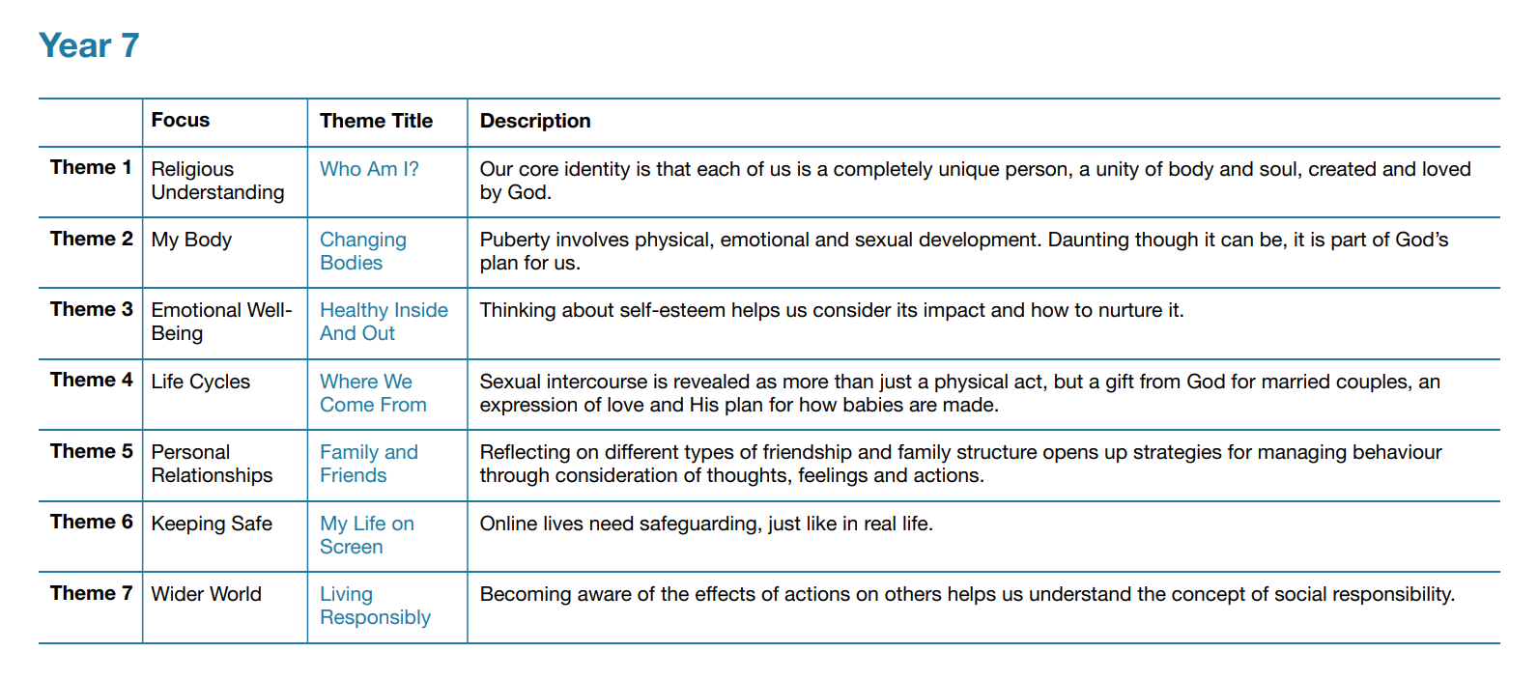
Topics also taught in Year 7 include
- Knife crime
- The Dangers of Drugs
- The Dangers of Alcohol
- Grooming- Recognising the Signs of Grooming
- Online Safety
- Impact of Peer Pressure
- Personal Safety including water, road and railway
- Combatting prejudice
- Appreciating Diversity
- The Dangers of Vaping
- Consent- Making Informed Choices
Appendix 1: RSE Curriculum Year 8
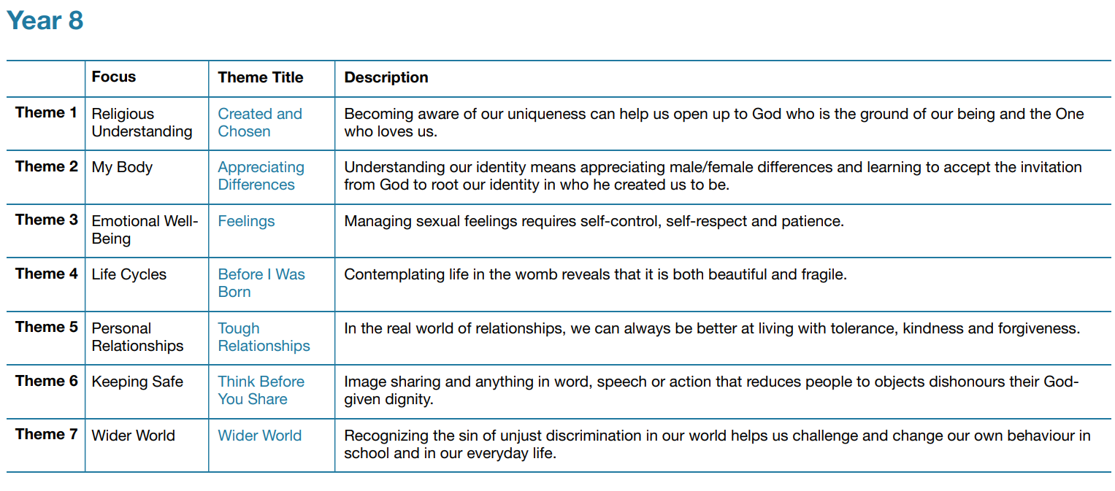
Topics also taught in Year 8 include
- Understanding Protected Characteristics
- Combatting Racism
- Prevent- Radicalisation
- Body Image
- Sexting and Appropiate Online Behaviour
- CEOP- Grooming
- Dangers of Vaping
- Drug Awareness (DECA)
- Female Genital Mutilation
- County Lines
- Financial Literacy
- Personal Safety- Including road, water and rail safety

Appendix 1: RSE Curriculum Year 9
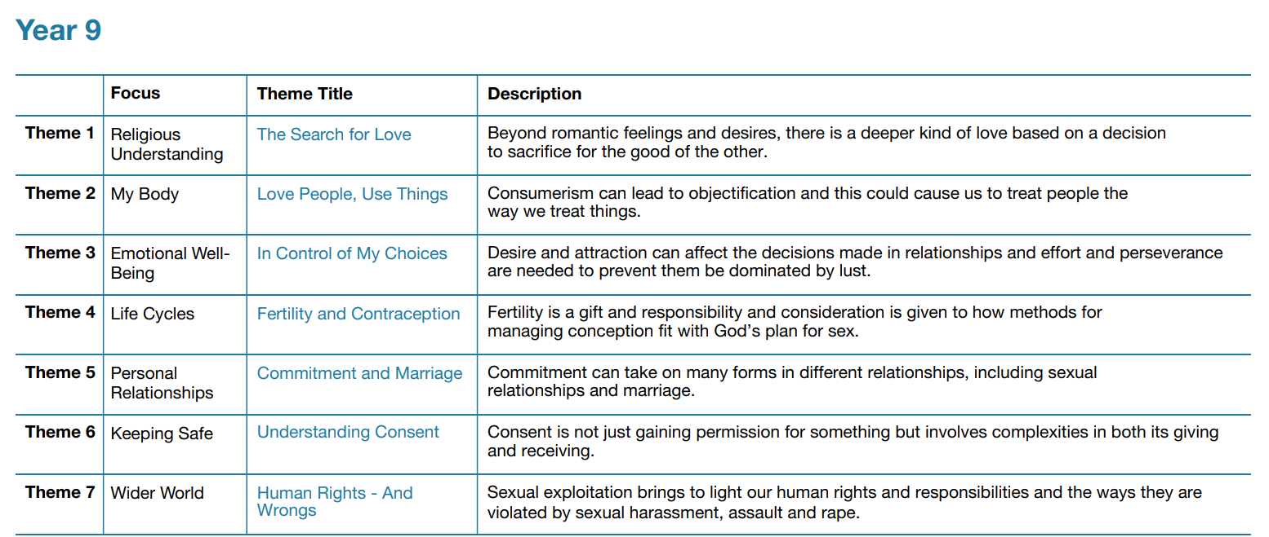

Topics also taught in Year 9 include
- Mysogny- What is it?
- Mysogny- How to combat it
- Phobic Bullying
- Sexual Harrasment and Stalking
- Knife Crime
- Gangs and Radicalisation
- The Dangers of Vaping
- Child Criminal Exploitation (CCE)
- Self Esteem
- Online Safety
- County Lines
- Mental Health First Aid
- Personal Safety including road, rail and water

Appendix 1: RSE Curriculum Year 10

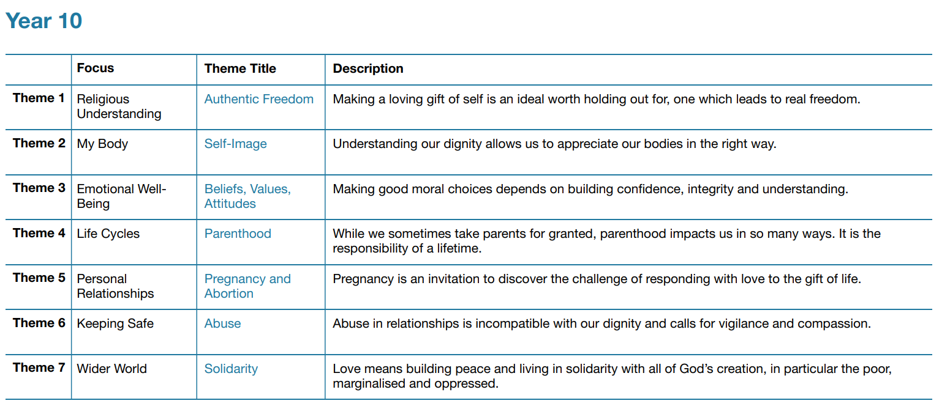
Topics also taught in Year 10 include
- Understanding Human Rights
- Honour Based Violence
- Forced Marriage
- Modern Day Slavery
- Financial Literacy
- The Dangers of Smoking and Vaping
- Domestic Abuse
- Radicalisation
- Mysogny
- Drugs, violence and gangs
- Online Safety
- Personal Safety including road, rail and water

Appendix 1: RSE Curriculum Year 11

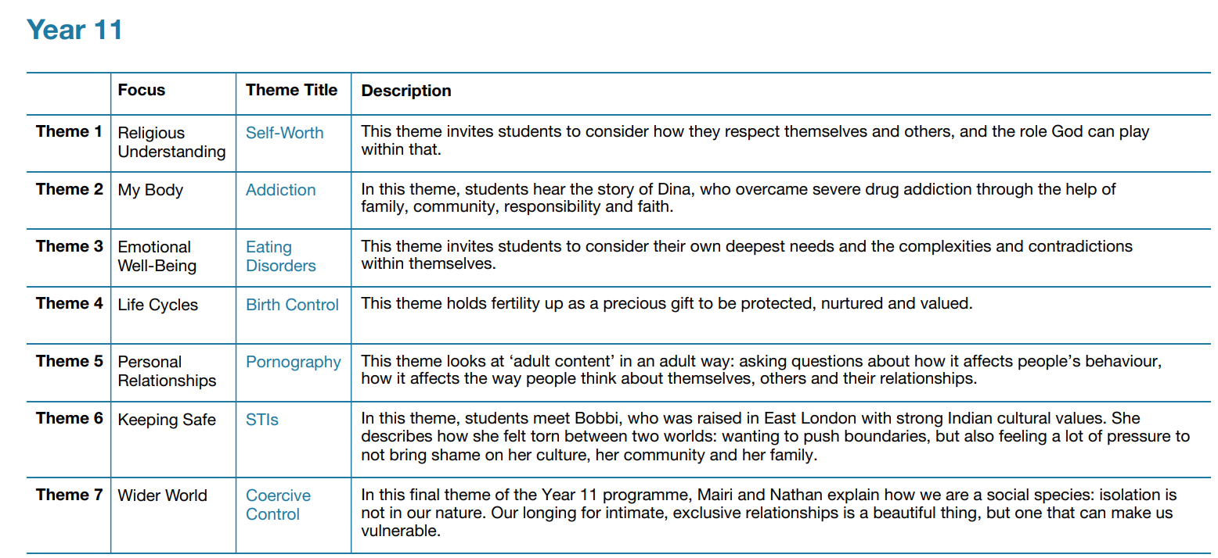

Topics also taught in Year 11 include
- Online Safety
- Mysogny and Incel
- Financial Literacy
- Consent
- Mental Health

Appendix 3: Parent form: Withdrawal from sex education in RSE

TO BE COMPLETED BY PARENTS
Name of child |  | Class
Name of parent |  | Date
Reason for withdrawing from sex education within relationships and sex education
Any other information you would like the school to consider
Parent signature

TO BE COMPLETED BY THE SCHOOL
Agreed actions from discussion with parents

