Bishop Milner Catholic College

Curriculum Policy for Intent and Implementation

‘Direct me in your ways, Lord, and teach me your paths. Encourage me to walk in your truth’.

Psalm 25:4-5

REVISED: Sept 2022
TO BE REVIEWED: October 2023

This document has been revised to bring policies for Curriculum, Teaching & Learning and Assessment & Feedback all into one place to give readers the necessary overview of our approach to these key areas of Quality of Education – and how we seek to monitor them as a college.

Criteria that informs the Content of the Curriculum
The curriculum provides areas of experience, which develop skills, knowledge, understanding and attitudes. These include:

- Social skills, cognitive/learning skills, analytical and decision-making skills as well as those related to particular areas of learning.

In addition, the National Curriculum is key, but does not represent the whole of the curriculum which should be available to our students. Bishop Milner Catholic College also aims to offer an entitlement to all students which should be:

BROAD - developing knowledge, concepts, skills, and attitudes in a range of areas of learning experience - aesthetic/creative (for example, through the Arts); human and social (for example, through Geography, History and Business Studies); linguistic and literary (for example, through English Language and Literature and Modern Foreign Languages); mathematical; scientific spiritual and moral (for example, through Religious Studies); technological (for example through Technology and ICT); vocational and work related (for example through BTECs at Level 2 and 3 in such subjects as Applied Law, Business Studies and Sport etc).

COHERENT - embracing the different areas of learning and experience, so that these do not appear as disparate subjects, but are linked to develop a holistic approach to students’ personal and social growth.

BALANCED - ensuring that each area of learning and experience will be given appropriate attention in relation to the others and to the curriculum as a whole.

RELEVANT - taking into account prior attainment and future needs, both in terms of progress within school and in the world beyond our college.

ABILITIES AND APTITUDES - aiming to ensure that teaching and learning styles, strategies and resources are appropriate to the needs of all Bishop Milner students and importantly, taking into account their wide range of abilities, aptitudes and expectations.

What attitudes and skills should the Curriculum foster and encourage?

All subjects (‘areas of learning experience’) in the National Curriculum and other subjects taught at Bishop Milner Catholic College have clear aims and objectives in terms of their specifications. Underpinning them all, however, there is a common core of skills and attitudes which we are endeavor to promote throughout all aspects of the college life. These include:

- The willingness to value and respect other people’s points of view, and to tolerate them even if they are not shared.
- The nurturing of attitudes which are open to new challenges and experiences whilst being prepared to question received wisdom.
- The willingness to develop responsibility for learning and conduct.
- The commitment to achieving the full potential of every individual.
- The commitment to lifelong learning beyond our college, and the flexibility to cope with future social, economic and technological changes.
- The development of ‘core skills’ in literacy, numeracy, ICT, political, economic, work related and environmental awareness to enable our students to play an active role as full citizens in the future.
The role of the Local Governing Body

The Local Governing Body has responsibility for ensuring that the college delivers an appropriate curriculum, which, for students between the ages of 11 and 19 must statutorily demands of the National Curriculum (including Religious Education). Through the Standards and Provision committee, The Local Governing Body plays an active role in the monitoring and evaluation of the curriculum. The Principal has a duty to ensure that the curriculum is delivered effectively and efficiently. Senior Leaders and Heads of Department at the college take prime responsibility for ensuring that what is taught is appropriate to the needs of students,
and delivered by staff with relevant expertise and training, using materials and methods which can fulfil the curriculum aims and objectives. In practice, all members of staff can contribute to this process through discussion and collaborative working. Other important influences on the nature of the curriculum at Bishop Milner Catholic College include:

- Students - through reviewing their work and partaking in Student Voice.
- Parents - through participation in parents evenings, meetings and surveys.
- Examining bodies as they determine external assessment methods and subject content.
- Ofsted - via an active response to current framework guidance and through inspection feedback.
- The Archdiocese of Birmingham – informed by Diocesan policy and practice that underpins Catholic education

Understanding Whole-College Curriculum and Pedagogy at Bishop Milner Catholic College
With our Catholic values at the heart of everything we do, we design and deliver our curriculum, knowing that our calling is to nurture compassionate, active and intentional young people who must be well prepared to go out into the world and fulfil God’s plan for them. We strive to offer the kind of curriculum that is varied and ambitious enough to help students be the best they can be, as community-minded citizens of modern Britain. Importantly, our students deserve knowledge and a love of learning that will remove barriers, create opportunities and pave the way for future success. Ultimately, our mission is to inspire hearts and minds with Christ at the centre of all we say and do.
So, how do we hope to achieve it?
We celebrate our position as a knowledge-engaged school: where the effective development of knowledge, skills and Gospel values are intertwined in our classrooms to enable students to benefit from the broad and balanced curriculum we work hard to offer – not least across a three-year KS3; where they keep their entitlement to a wider range of precious subjects for longer. Guided by learning theory, we place emphasis on the processes of memory, organisation and retrieval, and, the student-centred approach where learning is contextual to the individual, relies on language, and a collaborative relationship between student and teacher. We are proud when we say that, to us, relationships are everything.

When it comes to designing what will be taught, we believe that successful knowledge-gain should be cumulative and sequential. As a result, we operate a three-tiered approach of Long, Medium and Short-term Sequencing. Whether planning for the year, the topic, the week or the day, we rest our approach on the simplicity of two sets of questions: Where have students been? and Where do they need to get to? What do they need to know? and What must they remember to succeed? We don’t believe it is possible to assimilate new knowledge without having some structure developed from previous knowledge to build on, which is why (in support of the aforementioned sequencing) we ask for every lesson to be crafted upon: Today we need to KNOW and To succeed we must REMEMBER – empowering students to explore the links and connections between past, present and future learning. To support this expectation, all lessons begin with an act of Retrieval. We want our classrooms to be places of curiosity; where adults bring out in young people an excitement for learning and that hunger to know more and remember more.

Furthermore, knowing that access to (and application of) language is key, we also place considerable emphasis on the improvement and promotion of Reading across the curriculum: providing regular opportunities to explore text and subject-specific vocabulary. To improve confidence levels with challenging vocabulary students might need in all areas, we also teach ‘Language for Learning’ in Key Stage 3.

While staff in each separate subject area are passionate about helping students to create deep and long-lasting relationships with their academic discipline, we also understand the importance of working together across departments – finding ways to jointly celebrate common areas of knowledge, social and cultural themes and skills for later life. Furthermore, in active collaboration with our Primary and Secondary partners, our goal is to use knowledge of what students have studied at our feeder schools, and build upon those foundations in ways that seek to generate outstanding progress at secondary level and beyond. Working towards a 3-18 curriculum, is empowering us to understand the journey of education our students are on: motivating us to ask more targeted questions about how best to meet their academic, social, personal and spiritual needs.

While progress, outcomes and destinations for all students may signpost the impact of our curriculum, holistically, we look first and foremost to celebrate the happiness and successes (however small) of the whole child on their individual journey. For this reason, the Personal Development and Enrichment opportunities that support the Quality of Education we provide, are also incredibly important to us.

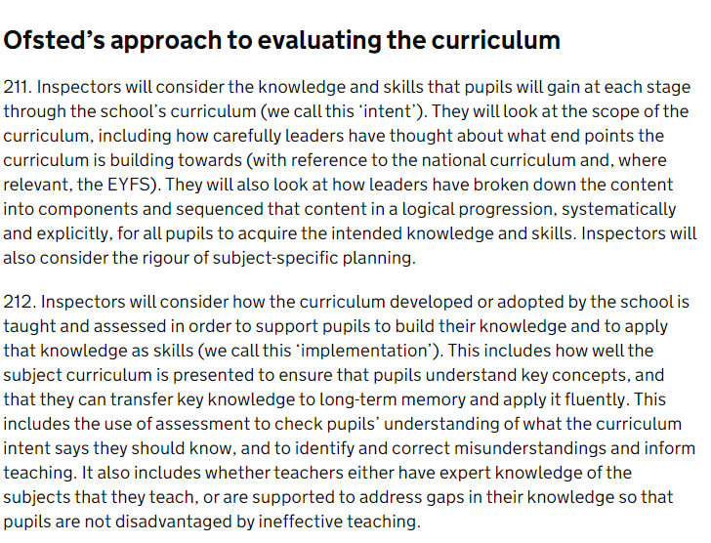

Understanding Approaches to Curriculum Planning at Bishop Milner Catholic College
Bishop Milner identifies as ‘Knowledge-Engaged’ school. This means that we recognise that both knowledge and skills need to be activated in order to secure success. This is embedded in to curriculums and planned for as follows:
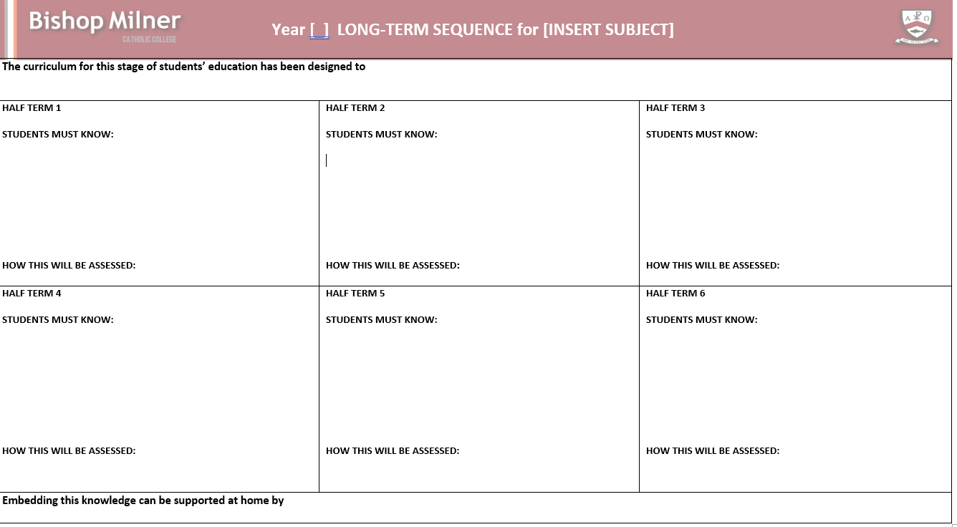
Long-term Sequencing: Yearly Sequences are reviewed annually for every subject and every year group -providing subject areas the opportunity to evaluate the effectiveness of the planning and delivery of their offering – making any changes/developments necessary. Each Long-term Sequence includes details of the intent of that curriculum within the year of learning, considering how knowledge and skills are sequenced and built upon. These documents also enable parents to see how they can build upon this learning outside of the classroom. They are stuck in the books of students to showcase the journey of learning for the year ahead.

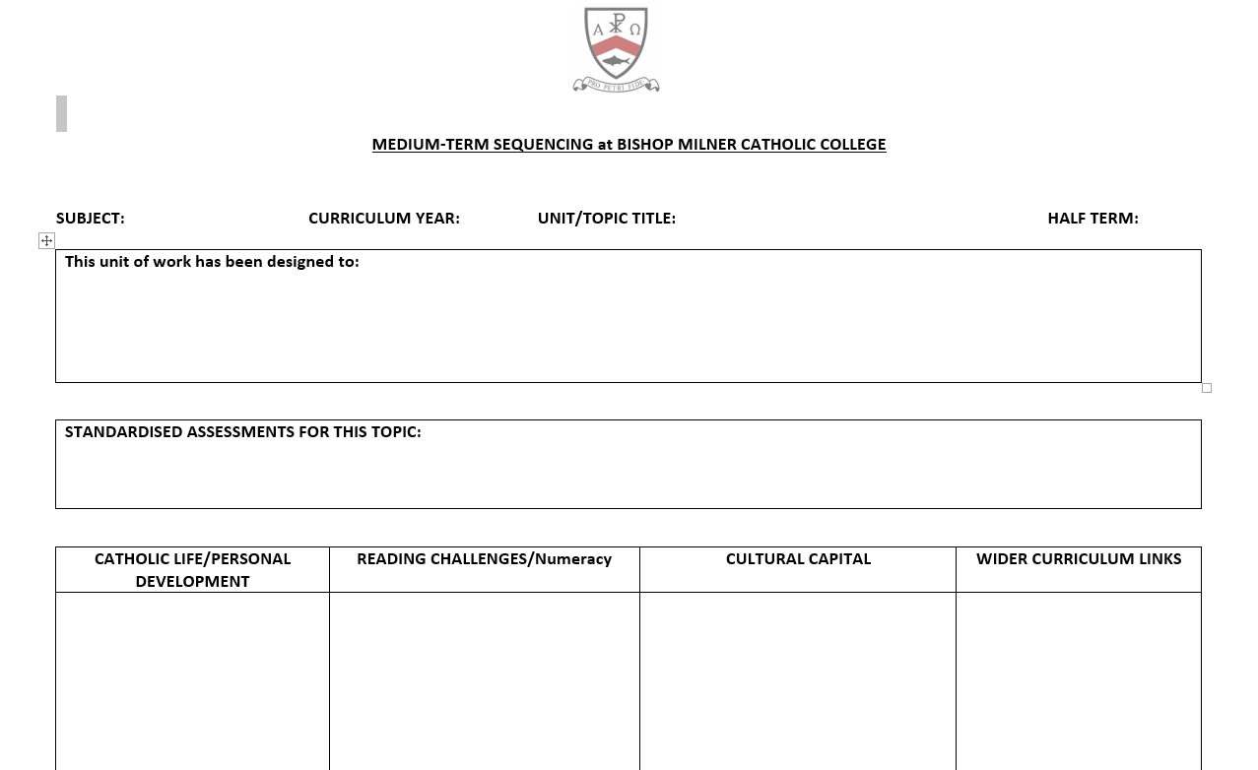
Medium-term Sequencing: As each year of learning is broken down, greater emphasis is also placed on the deliberate sequencing of curriculum delivery from one week to the next – to help us ensure that within any given topic or unit, the right things are being taught in the right order and for the right reasons. Writers of curriculum identify the knowledge or skills required for that week before moving on to the next.

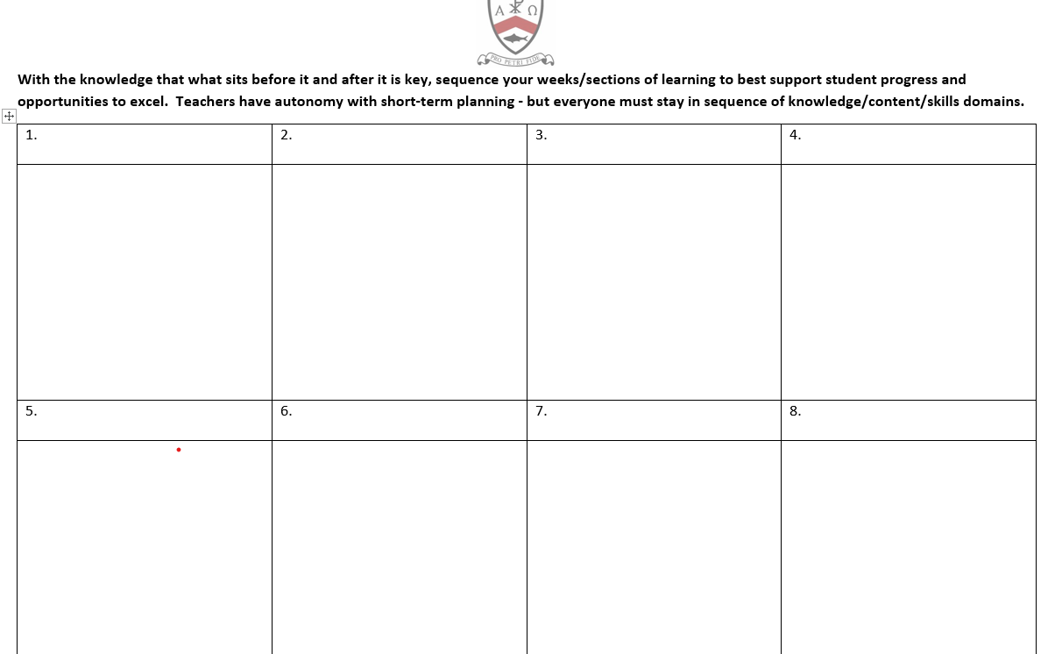

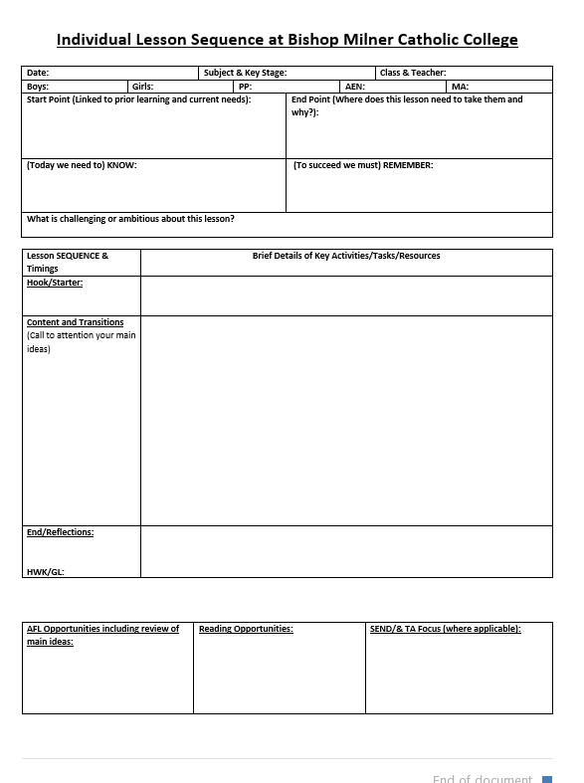
Short-term Sequencing: Teachers are expected to deliver excellent lessons, with the highest standards of teaching and learning, according to policy. However, this comes with the expectation that no lesson ‘stands alone’, but makes sense in terms of what goes before and after it.
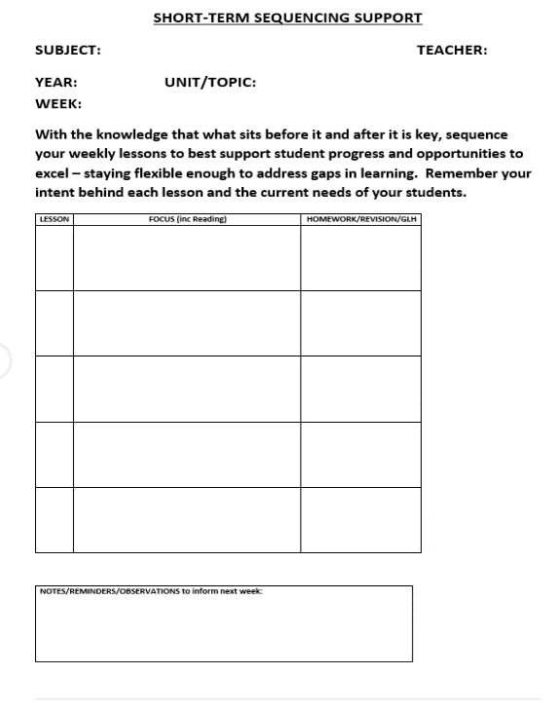
Cultural Capital Offering: Different areas of the college also map provision to reflect how their curriculum (and extra offerings) is intended to boost the life chances of students. This area of planning is also re-visited annually to keep it thriving and up-to-date.
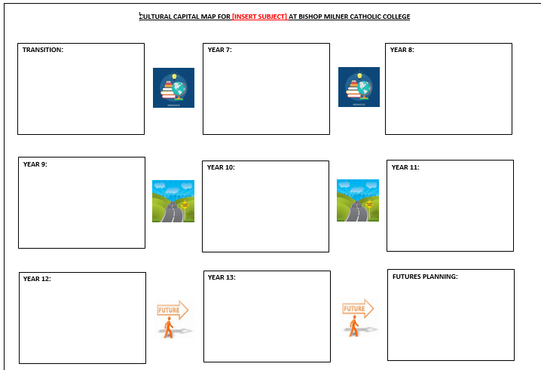

Staff Involvement: All subject staff (not just middle leaders) are expected to contribute to curriculum design and its resourcing. They are also expected to live out the intent behind the journey of students in their short, medium and long-term practice.

How do we monitor and evaluate our Curriculum?
The process of monitoring and evaluation of the curriculum is ongoing linked to the roles of the Local Governing Body, Senior Leaders, Heads of Department and all staff. The effectiveness of the curriculum offer is closely aligned to:

- External examination results (e.g. BTEC’s at Level 2, GCSE’s, BTEC Nationals and A levels) and associated benchmarking and progress indicators linked to SIMS, etc.
- Heads of Department analysing their external examination results which forms the basis of a review meeting with Senior Management which takes place in the first half of the Autumn Term and also post mock examinations in Year 12 and 13 (January)
- Internal data collection encompassing evidence produced by class teachers, departments and whole college.
- Review meetings between Heads of Department and Head of School/Lead SLT member for Data on a half termly basis following links to student progress, attainment and attitude data.
- Regular communication between Heads of Department and the Lead SLT member for Teaching, Learning and Assessment.
- Whole college monitoring (and subsequent action points) of Teaching and Learning, and marking and feedback.
- Quality of Education Reviews to delve more deeply into individual subject areas and their approaches.
- Whole college appraisal objectives linked to curriculum priorities.
- Reports to the Local Governing Body and to the Board of Directors.
- ‘Recruitment and Retention’ data linked to the intake at KS3 and the options process for both KS4 and KS5.
- Career and further/higher education pathways at 16+ and 18+.
- Other data which can be considered to assist monitoring and evaluation includes attendance, unauthorised absence statistics and exclusion rates etc.

Set Criteria helps us to monitor the implementation of our curriculum in lessons and in the books and folders of students:

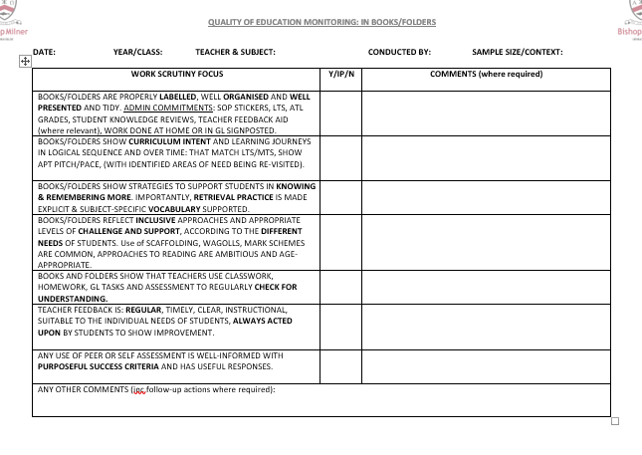

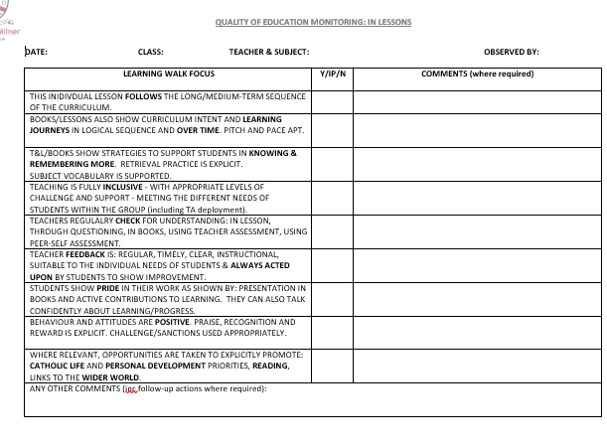

Where can parents/carers find details of curriculum sequencing within subject areas?

Subjects studied at Bishop Milner Catholic College including course content and other associated information can all be found on the college website in our curriculum area: www.bmilner.dudley.sch.uk

The importance of Subject Disciplines
At Bishop Milner, we also believe that subject-specific approaches to curriculum and pedagogy are more powerful and purposeful than generic whole-school ones. This is why, each department builds their own Subject Handbook to detail their approaches. Secondary teachers are specialists who should understand the needs of their curriculum, the most likely misconceptions of students, and what constitutes best practice, better than non-specialists. Therefore, while lessons across Bishop Milner share common approaches and ingredients, it is within department areas were the most important consistencies should be found. Subject Handbooks provide clarification on: Curriculum Intent, Theory & Research, Curriculum content, Reading, Teaching and Learning, Assessment, SEND provision, Quality Assurance and CPD.

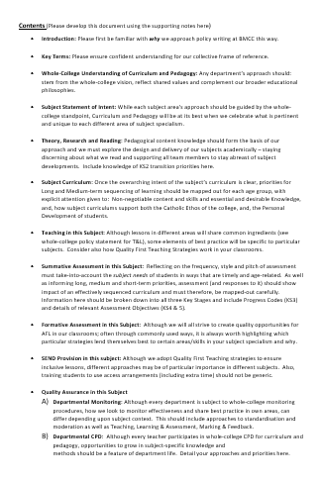
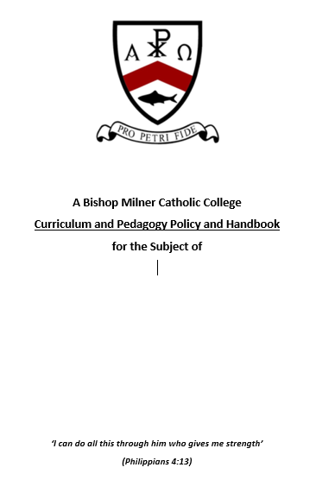

How is the Curriculum delivered at BMCC?
In addition to Individual Subject Handbooks (and to support whole-college expectations), documentation for Teaching, Learning & Assessment, Presentation, Marking & Feedback, Reading and SEND provision by teachers, have been streamlined into policy statements that focus on 5 core priority areas. Please find them enclosed.
Placed alongside Teachers’ Standards, it is the responsibility of every teacher, with the support of their appraiser, to commit fully to all principles within each statement; providing students with the highest quality of education they deserve. Here is a summary of common ingredients across subjects and lessons:
- ‘Today we need to KNOW’ is a compulsory focus for each individual lesson.
- ‘To Succeed we must REMEMBER’ is a compulsory focus for each lesson.
- Lessons begin with an act of RETRIEVAL PRACTICE that should be explicitly acknowledged.
- Marking work with the ‘Here and Now’ philosophy is compulsory because students deserve to be provided with recognition and praise for their achievements, and, clear and instructional next steps for learning.
- Students should reflect upon each topic or unit of work by completing a mini review to consider what knew knowledge they have gained and how this learning could help them in later life.
- Teachers are encouraged to make use of a common feedback aid to support AFL, focus DIRT and prioritise bespoke progress tasks.

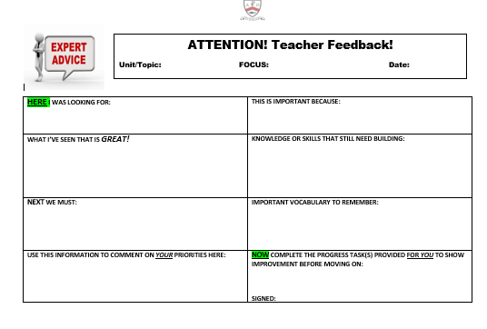
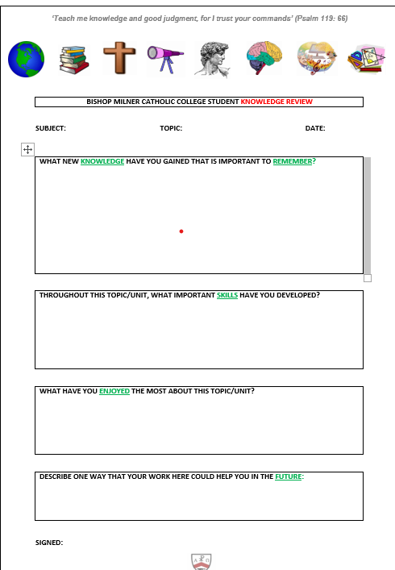

As teachers who love what we do, on-going CPD for Curriculum, Teaching, Learning and Assessment is a priority throughout the academic year and is conducted in a variety of ways. All teachers are called on to be active participants and contributors. All ECTs and trainees also receive additional CPD and support.
- Fortnightly Theory and Practice Forum for staff to explore research-based approaches to curriculum and its implementation.
- Fortnightly Curriculum Middle Leaders Forum for Subject Leads to keep abreast of curriculum priorities.
- Subscription to The National College for access to regular and up-to-date training materials.

At Bishop Milner, we proudly assert that ‘anything less than good, is not good enough’, and with our Catholic Ethos at the heart of everything we do, we remind ourselves: ‘If your gift is serving others, serve them well. If you are a teacher, teach well’.

Policy Statement for Teaching, Learning & Assessment at Bishop Milner Catholic College
All teachers at Bishop Milner are expected to sustain exemplary subject knowledge and to know and fulfil all relevant Teachers’ Standards.
For Teaching and Learning to be the best it can be, we must commit daily to our 5 main priorities…
- Relationships
- Be role-models of compassion, ambition and respect.
- Live out our calling as teachers in Catholic Schools.
- Create warm and welcoming environments.
- Establish trust through high expectations, clear boundaries and support.
- Praise first. Always Listen.
- Behaviour for Learning
- Apply systems of behaviour management fairly and consistently.
- Champion common routines, expectations and boundaries.
- Create classrooms where students can be leaders.
- Create environments that students want to learn in.
- Provide a range of engaging stimulus and opportunities.
- Invite all students to be active and not passive.
- Structure and pace lessons appropriately.

- A Solid Consensus and One Common Language for Learning
- Understand the principles of ‘Knowledge-engaged’ learning and facilitate them in your classroom by planning and resourcing rigorously and creatively to: prioritise recall and retrieval, embed new knowledge and highlight relevant skills, with explicit focus on the importance of sequencing.
- Plan lessons (and sequences of lessons) with the goal of helping students to KNOW and REMEMBER more. Make links between prior, current and future learning explicit. Refer often to the relevance, place and purpose of learning.
- Complete Knowledge Reviews with students at the end of every unit/topic.
- Use agreed whole-college strategies to enhance Reading and Writing across the curriculum.
- Recognise and use opportunities for number skills when they arise.
- Nurture a love of learning outside of the classroom through links to the wider word.

- Meeting the Needs of All Students
- Stay fully inclusive through the use of Quality First Teaching methods.
- Provide stretch and challenge for all without overlooking the fundamental act of recall.
- Remove barriers to language and learning with a keen focus on subject literacy and Tier 3 vocabulary.
- Provide regular WAGOLLs: model excellence and deconstruct the process of getting there.
- Use the strategy of ESSENTIAL – IMPRESS – AMAZE to highlight varying degrees of challenge.
- Increase your focus on the views of Teaching Assistants and deploy them effectively.
- Embrace and contribute to regular CPD.
- Understanding Assessment
- Facilitate challenge in all Key Stages and conduct assessments (according to MTS) that are appropriately pitched.
- Use assessment data to inform planning and teaching: know your groups inside-out.
- Teach lessons with a wealth of AFL opportunities – empowering you to efficiently identify and act upon gaps.
- Assess accurately, undergoing processes of moderation and standardisation.
- Regularly update systems of monitoring and tracking.
- Use assessment knowledge to target gaps in the learning of students and determine the appropriate interventions.
- Mark with purpose and a focus on instructional feedback with the required follow-up.
- Ensure accurate entry of data to inform wider systems of monitoring, support and intervention.

Policy Statement for Presentation, Assessment, Marking and Feedback at Bishop Milner Catholic College
All teachers at Bishop Milner are expected to use their subject knowledge to provide students with regular feedback that secures progress by: praising achievement, providing explicit instructions and making time for students to show improvements. With the highest standards of presentation insisted upon, books and folders should proudly show the journey of learning over time.

For evidence of progress to be the best it can be, we must commit routinely to our 5 main priorities…

Presentation
- Keep expectations high and stay relentless in your insistence on well presented, well-kept work.
- Understand that excellent presentation is about so much more than appearance – it is the mark of pride, value and worth.
- Books and folders must: be labelled with Name, Teacher, Subject and Room, display up-to-date SoP data, have copies of LTS and the college ATL grades inside.
- All work (that must be written in black ink) must also be headed with underlined dates and titles. The teacher decides if it is appropriate for the ‘KNOW’ criteria to be recorded.
- All paper and sheets must be securely fastened or stuck inside.
- Poor presentation must be challenged and rectified.

Teacher Feedback and Responses to it
- Provide students with regular feedback in accordance with Subject requirements. Personalised handwritten feedback will be shown in red pen (typing or use of stickers or stamps is acceptable) but all entries must adhere to policy and be dated. To reduce the workload of teachers, it is acceptable for some (not all) entries of feedback to take the form of our whole-college Teacher Feedback Aid.
- Be it individually written feedback, or comments populated for a class, adhere to the ‘Here and Now’ principle of marking which is:
HERE: (Positive acknowledgement and recognition of achievement/attainment).
NOW: (An instructional command for progress to be made – where the task should be bespoke or meet the needs of individuals).
- Always provide students with the dedicated reflection time needed to follow these instructions and complete required improvements. No teacher feedback must be left without response. This progress is shown using purple pen.
- To allow feedback to be a driving force of progress, be discerning with which pieces you choose to mark.
- All teachers must champion high standards of SPAG.
- Dialogue on achievement and improvement should pervade your classroom. Give verbal feedback frequently.

Self and Peer Assessment
- Give students the guided opportunity to reflect on their own achievements and suggest targets for their own improvement. The teacher will decide where and when this is useful.
- Give students the guided opportunity to reflect on the achievements of others and suggest targets for their improvement. The teacher will decide where and when this is useful.
- These contributions are shown using green pen.
- Always control how purposeful these entries are and avoid redundant offerings by establishing clear, easy-to-use success criteria and checking responses to it.

Summative Assessment and Graded Work – In line with Departmental Policy
- Plan for regular and standardised opportunities to grade the work of students. Actual grades should be displayed/considered against target grades.
- Ensure routine use of ‘test conditions’ to assess unaided progress and to prepare students for formal examinations.
- In KS3, make explicit use of Progress Codes on assessment work to show how grades have been determined and to highlight targets for improvement.
- In KS4 and 5, make explicit use of mark scheme content on assessment work to show how grades have been determined and to highlight targets for improvement.
- Distinguish assessment work from draft work (in the way it is stored and/or presented) to recognise its importance. Always keep assessed work (or a copy of it) in college.
- Keep robust systems of the monitoring and tracking of graded work to help determine the necessary interventions.

- Crafting Progress
- In addition to instructional feedback and purple progress work, books and folders should showcase active use of modelling and exemplar materials (WAGOLL).
- WAGOLL/Scaffolding materials should also be deconstructed and annotated to help students break down the process of how excellence is achieved.
- Make active use of mark schemes and Progress Codes when preparing for (and reflecting on) achievement and improvement. Ensure that materials used are accessible and student-friendly.
- Make active use of our whole-college strategies for Reading and Writing across the curriculum.
- Use writing frames and other scaffolding materials to support progress in books and folders where required.
- Practice of extended writing should be seen where possible.
- Understand that books/folders/computer-stored work give witness to progress over time. They provide documentation of every students’ learning journey and should be built up with great care and consideration.

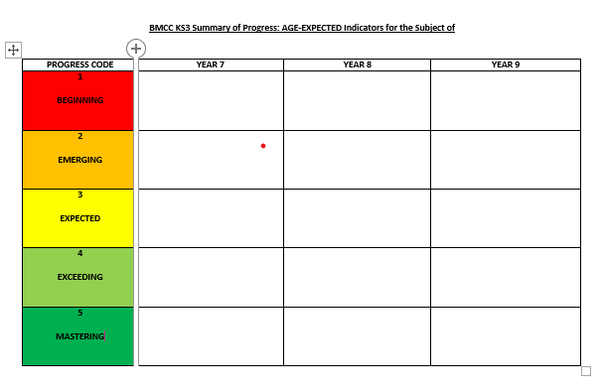

For KS3 Assessment, departments carefully establish what knowledge and skills students should demonstrate at different stages in order to secure Age-expected progress on their journey towards GCSE. With student starting points and targets in mind, we can then monitor if they are progressing at the right rate.

Policy Statement for READING at Bishop Milner Catholic College
Reading is the most crucial literacy skill for cross-curricular success. Effective teaching, a knowledge rich curriculum and literacy skills are inextricably linked to allow all learners, including the most disadvantaged and those with greater needs, the knowledge and the cultural capital to succeed in life. Our learners need regular opportunities to read in a range of subjects, allowing them to build their fluency and comprehension skills to provide them sufficient access to the full curriculum. All teachers at Bishop Milner are expected to enable equitable access to their curriculum through appropriate support and challenge in reading. Lessons provide opportunities for retrieval practice of Tier 3 vocabulary; teacher exposition and modelling of reading aloud; plus opportunities for student reading and activities that focus on enhancing reading skills; provision of further reading opportunities through Preparatory Study. Ultimately, our approaches to reading within college should challenge and enhance students’ skills - enabling them to become confident and independent readers.
Common Strategies for the Teaching of Reading
Teachers planning lessons should have good knowledge of reading material suitable to their subjects that will be used to provide relevant challenge for their students. Texts that are chosen should be ambitious and challenging, reflecting the knowledge and skills required for that topic at that phase of learning. Teachers will be consistent in their use of language to describe key terms, and provide learners with repeated exposure to expert modelling, opportunities for oral rehearsal and finally guidance required to replicate the reading independently. Retrieval questions will balance the recap of previous vocabulary with acquiring new knowledge. Use of the whole college reading strategies (DARTS, Word Level Reading and Questioning) will support and challenge students in their reading and ability to access the material required for learning. Medium-Term Sequences of lessons should also consider the glossary of Tier 3 Vocabulary required to unlock the learning power of students during that particular stage of their journey.
An Active Diet of Reading Each Day:
Teachers will plan, prepare and deliver lessons that take in to account the reading needs of students they teach: ensuring that opportunities for expert modelling of reading are made explicit. Experiencing reading in action is essential to develop skills and understanding. Before reading complex texts, key vocabulary should be explicitly pre-taught to aid comprehension and retention. Active reading should be applied to a varied range of text-types and there should be an example of active reading in EVERY lesson. Short-Term Sequences of lessons should also consider how key subject terms should be learnt or re-visited, in order for students to access new knowledge. Departments will provide varied and engaging ways of promoting key vocabulary within their subjects.
P Promoting Wider-Reading Across the Curriculum:
Departments should expand the opportunities for reading within each academic discipline - empowering students to develop knowledge of their subject through reading. This can be provided through guided reading as part of ‘Preparatory Study’ and pre-reading lesson materials or targeted research. The use of Subject Specific Reading Lists, reading notice boards, reading prompts as part of classroom displays, competitions, research and pre-reading activities should also support the broadening of reading around subjects. Teachers will support various fun initiatives to help promote fluency, comprehension and vocabulary across the school. Year 7 and year 8 students are also given a Reading Journal and expected to record the extra reading they do outside of college hours.
Addressing the Gaps:
Students who enter college are assessed in reading, providing a Reading Age and Standardised Score (reading assessments are completed twice yearly). Those who are identified as needing further support will be enrolled on to a reading recovery programme (Year 7 & 8) to include further reading tuition and intervention and reading support at home. Identification of their difficulties will be shared with staff, along with suggested strategies, to support reading across the curriculum. Regular CPD on Reading and SEND will be facilitated to give teachers and support staff confidence when nurturing the reading skills of the students they work with. Where possible, support staff will also play a key role in reading interventions outside of the classroom.

Policy Statement for the Contribution of Teachers to Effective Provision for SEND Students

All teachers at Bishop Milner are expected to strategize and adapt their teaching to support, and increase the confidence of, students in our community with recognised barriers to learning. The highest quality of education that all students deserve must be fully inclusive at all times.
For the support of SEND students to be the best it can be, we must commit sensitively to our 5 main priorities…
- Knowledge and Understanding
- Be familiar with the up-to-date SEND Code of Practice to understand the legal duties and responsibilities of mainstream schools.
- Have high expectations for each and every student, whatever their prior attainment.
- Ensuring Quality First Teaching, that meets the needs of individuals, is the first step in responding to pupils who have or may have SEN.
- Ensure knowledge and understanding of the SEND needs of any student you teach.
- Make active use of any strategies/advice provided by the SEND team.
- Be pro-active in sharing information or seeking advice when concerns surrounding SEND students arise.
- To accompany data, complete review and intervention planning and constructively and on time.
- Preparation
- Be sure that the layout of your classroom and the seating arrangements within it meet the individual needs of students.
- Adjust task or approach where required – do not reduce the quality, skill or aspiration.
- Facilitate amended resources to allow students to work efficiently and never ask them to copy large amounts of text.
- Employ approaches and create regular opportunities for visual and auditory stimulus.
- Make regular use of scaffolding, writing frames, glossaries and other vocabulary support.
- Recognise the need for additional praise and reassure for students who often have anxiety or nerves surrounding learning and work hard to remove a fear of failure.
- Make active use of information shared in CPD sessions and SEND briefings.

- TA Deployment
- Recognise the knowledge, skills and experience of TAs by empowering them to play an active role.
- Communicate routinely with TAs – sharing the intent and direction of learning.
- Use the starts of lessons to make it clear to TAs what is required – providing any resources/advice they will need.
- Give TAs enough autonomy to work in ways that they know best suit their targeted students.
- Ask for and listen to the views of TAs on: the needs of targeted students, what’s working and what isn’t, the same students in other subject areas.

- Access Arrangements
- When it comes to assessments and examinations, know the entitlements of students.
- Provide these entitlements routinely and consistently to give students the best chance of using them to full effect.
- Gather and provide evidence as requested to help sustain the eligibility of students for access arrangements.
- Coach students on how to utilise extra time as an inbuilt part of their assessment; not just an add on at the end.

- Student Voice
- Receive information from the college’s SEND review process openly and sensitively.
- Be prepared to alter your approach in the classroom following feedback from SEND reviews.
- Take advice from the SEND team on how best to respond to confidence issues of students that present themselves.

