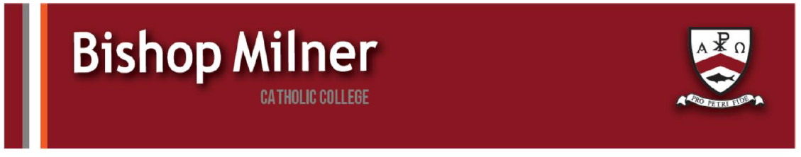
Careers support and information
Doocey Group have multiple Apprenticeship & Apprenticeship Degree Opportunities this Year.

Level 2 Highways Maintenance Skilled Operative
No Level 4 barriers (no GCSEs C in maths or English)
No age barrier (you can be an apprentice at any age!)
No gender barrier ( we have had 4 female apprentices to date!
Free 3-week pre-apprenticeship gaining 5 qualifications
If successful, 15-month level 2 Skilled Highways Maintenance Operative apprentice qualification
After successful completion of apprenticeship starting salary is £32,500.

Level 3 Business Administration Assistant – various sectors
Level 4 in Maths and English minimum requirement (apply with predicted grades)
15 month Apprenticeships available in different divisions of the business
Able to meet staff and discuss options at the Open Day
Pupils will need to scan the QR code to register for the event - they can attend with friends, parents or carers or on their own.

- Careers in Fire Safety:

Please see the attached FSE leaflet.

We’re looking for practical and personable people who aren’t interested in sitting in an office all day to think about a career in fire safety. Fire Risk Management an interesting, rewarding (and well-paid) career with job security and nationally recognised qualifications. You need to be smart, but not traditionally academic and those who like the idea of travelling around the country, meeting people, and developing technical skills are the perfect fit.

Right now, there’s more work than there are skilled people to do it; employers are actively hiring those they can help develop and train. We know that there are plenty of young people hungry to fill that gap. That’s why, alongside the Fire Safety Event, RiskBase are hosting a networking session at the Birmingham NEC on the 29th of April. This is the UK’s biggest industry event with 10,000 professionals and all major employers under one roof.
The session starts at 3:30pm on the Leadership Stage - a genuine chance to hear from the people at the top of the sector and understand exactly what a successful career in fire safety looks like. Afterwards attendees will be invited to an exclusive drinks reception to meet and network with these industry leaders and top employers in an informal and friendly setting.
If this sounds like any of the students or jobseekers in your organisation, this is a room they should be in. The event’s free to attend, just register for an invite and we look forward to seeing you there.
For more information, please contact:

Archie Donald
07849 644 949 / 020 8973 1063
Email: archie.donald@riskbase.uk

