
Bishop Milner Catholic College

Relationship, Sex and Health Education (RSHE) Policy

‘Inspiring hearts and minds with Christ at the centre of all we say and do’

Review Date: September 2027

Relationships Sex and Health Education Policy
“Inspiring hearts and minds with Christ at the centre of all we say and do”

Policy information | Details
Policy owner | Assistant Principal for Catholic Life and Personal Development
Approval body | Local Governing Body
Effective date | Approved 23/09/2026
Review cycle | Annual, or sooner following statutory change
Next review | September 2027
Status | Statutory policy

1 Purpose and status
This policy sets out how Bishop Milner Catholic College provides Relationships, Sex and Health Education (RSHE) from September 2026.
Bishop Milner Catholic College is a secondary academy and provides relationships and sex education in accordance with the Relationships Education, Relationships and Sex Education and Health Education (England) Regulations 2019. Bishop Milner Catholic College follows the Department for Education statutory guidance that came into effect on 1 September 2026. Safeguarding practice follows Keeping Children Safe in Education 2026 and other current statutory safeguarding guidance.

2 Catholic character and guiding principles
At Bishop Milner Catholic College, every pupil is loved by God and made in the image and likeness of God. RSHE forms part of the education of the whole person and is rooted in the dignity of human life, the call to love, the virtues, and the Catholic understanding of marriage, family life, sexuality and responsible relationships.

3 Aims
- to help pupils know that they are loved and made in the image of God;
- to develop reverence for human dignity, sexuality and fertility;
- to enable pupils to form and sustain healthy, respectful and nurturing relationships, including friendships, family relationships and, in adult life, intimate relationships;
- to build self-respect, confidence, empathy, resilience, kindness, care and responsibility;
- to provide accurate knowledge about bodies, puberty, reproduction, sexual and reproductive health, and physical and mental wellbeing;
- to develop the skills to recognise boundaries, communicate consent, resist pressure, manage conflict, end relationships safely and seek help;
- to prepare pupils to stay safe from abuse, exploitation, harassment and harm, including online and AI-enabled harms;
- to teach applicable law, equality and protected characteristics factually and respectfully; and
- to prepare all pupils for the opportunities, responsibilities and experiences of life in modern Britain.

4 Curriculum organisation and delivery
RSHE is delivered principally through Personal Development and the SAINT Tutor Curriculum. Certain topics are covered in greater depth in Religious Education and Science lessons.
The RSHE curriculum is planned using diocesan-approved resources, including appropriate Ten Ten Resources materials. These resources form the basis of the RSHE curriculum. Their use does not replace the College’s duty to teach statutory factual, scientific, medical and legal content accurately and impartially.
Where a particular need is identified, the College may teach a topic in single-sex groups, provided this is educationally justified, inclusive, avoids stigma and does not deny any pupil the statutory content they need.

5 Supporting all students to access the curriculum
RSHE will be accessible to pupils with special educational needs and disabilities. Staff will make reasonable adjustments, differentiate language and resources, pre-teach vocabulary where helpful, use concrete examples and repetition, and work with the SENDCO, families and relevant professionals.
Planning will recognise that some pupils with SEND may be especially vulnerable to exploitation, harmful sexual behaviour, abuse, online manipulation and misunderstanding of social cues. Teaching will therefore give explicit attention to boundaries, consent, communication, reporting routes and trusted adults, without lowering expectations or denying access to statutory knowledge.

6 Staff training and external providers
Staff delivering RSHE will receive appropriate curriculum, pedagogical and safeguarding training. They will know how to create a safe environment, facilitate participative learning, respond to disclosures and signpost support. Any concerns about delivery should be raised with Mr Baker (RSHE lead)
Bishop Milner Catholic College remains responsible for all content delivered by an external provider. Before engagement, the College will:
- check the provider’s credentials, safeguarding arrangements and suitability;
- review the lesson plan and all materials in advance for factual accuracy, age and stage appropriateness, accessibility, bias and fit with this policy;
- agree learning outcomes, staff presence, confidentiality and how safeguarding concerns will be reported; and
- evaluate the session and retain oversight of follow-up teaching.

7 Openness with parents and curriculum materials
Bishop Milner will engage parents proactively about what is taught and why. On request, parents may view all curriculum materials used to teach RSHE, including materials supplied by external providers.
Access will be arranged in a way that respects copyright, for example through a secure parent portal, an on-site viewing or a presentation. Parents may not veto statutory curriculum content, but their views will be considered through consultation and review.
If emerging needs require a material departure from the published programme, we will inform parents in advance where practicable and will continue to make relevant materials available on request.

8 Difficult questions and sensitive issues
Teachers at Bishop Milner Catholic College will answer questions honestly, factually, sensitively and in an age-appropriate way. They may defer a question for individual follow-up where a classroom answer would be inappropriate, unsafe, outside the planned curriculum or likely to disclose personal information. They will not shame a pupil or leave a safeguarding concern unaddressed.

9 Safeguarding confidentiality and disclosures
RSHE is taught in accordance with Keeping Children Safe in Education 2026. Staff will never promise absolute confidentiality. Pupils will be told that information will be shared only with those who need to know when this is necessary to keep someone safe.
Any concern or disclosure must be acted on immediately in accordance with the safeguarding and child-protection policy. The member of staff must notify the Designated Safeguarding Lead or deputy and record the concern using the College’s approved system. Mandatory reporting duties, including those relating to female genital mutilation, must be followed.
Teaching at Bishop Milner will make clear that abuse is never the victim’s fault and will identify internal and external reporting and support routes. Where an external agency delivers a session, arrangements for handling a concern will be agreed in advance.

10 Rights to request withdrawal from sex education
Parents and carers have the right to request that their child be withdrawn from some or all sex education delivered as part of statutory RSHE. They do not have the right to withdraw a pupil from relationships education, health education, or any content taught as part of the science curriculum, including puberty and sexual reproduction.
A request should be made in writing to the Executive Principal using the form in Appendix 2 or by equivalent written communication. Before deciding the request, the Executive Principal will discuss it with the parent and, where appropriate, the pupil. The discussion will clarify the nature and purpose of the curriculum, the content covered, the benefits of participation and the possible social, emotional and informational effects of withdrawal. A written record will be retained.
The Executive Principal will normally grant a secondary-school request, but may refuse it in exceptional circumstances, for example because of safeguarding concerns or a pupil’s specific vulnerability. The decision and reasons will be communicated to the parent. A pupil who is withdrawn will receive appropriate, purposeful education during the lesson.
From three terms before the pupil turns 16, the pupil may choose to receive sex education despite an earlier parental request for withdrawal.

11Roles and responsibilities

The Local Governing Body will:
- approve this policy and oversee compliance;
- ensure the statutory curriculum is resourced, monitored and reviewed;
- assure itself that parental consultation, material transparency, equality, SEND accessibility and safeguarding expectations are met; and
- hold the Assistant Principal i/c Personal Development to account for implementation.

The Executive Principal will:
- ensure consistent implementation across the College;
- decide requests for withdrawal from sex education;
- ensure staff and external providers are suitable, trained and supported; and
- ensure concerns are handled through the safeguarding framework.

The Assistant Principal i/c Personal Development will:
- maintain a complete, sequenced curriculum map and schemes of work;
- coordinate Personal Development, RE, Science and other subjects;
- quality-assure resources and external provision;
- arrange parent access to materials; and
- monitor teaching, learning and pupil outcomes.

Staff will:
- deliver RSHE sensitively, accurately and inclusively;
- model respectful attitudes;
- apply reasonable adjustments and respond to individual needs;
- follow the difficult-question and safeguarding procedures; and
- direct pupils to reliable help and support.
Pupils are expected to engage appropriately and treat others with respect and sensitivity.

12 Monitoring evaluation approval and review
Implementation will be monitored through curriculum mapping, lesson visits or learning walks, work and resource scrutiny, pupil and parent voice, staff feedback, assessment information, safeguarding intelligence and review of external provision. Monitoring will consider statutory coverage, sequencing, age appropriateness, accessibility, factual accuracy and impact.
This policy be reviewed at least annually and sooner if legislation, statutory guidance, safeguarding requirements, local need or curriculum evidence changes. Any significant policy revision will include appropriate consultation.

13Related legislation and guidance
- Education Act 1996, section 403, and Education Act 2002, section 80A;
- Relationships Education, Relationships and Sex Education and Health Education (England) Regulations 2019;
- Department for Education, Relationships Education, Relationships and Sex Education and Health Education statutory guidance, effective 1 September 2026;
- Department for Education, Keeping Children Safe in Education 2026;
- Equality Act 2010, including the public sector equality duty where applicable;
- Working Together to Safeguard Children; and
- SEND Code of Practice 0 to 25 years.

Appendix 1: RSE Curriculum Year 7
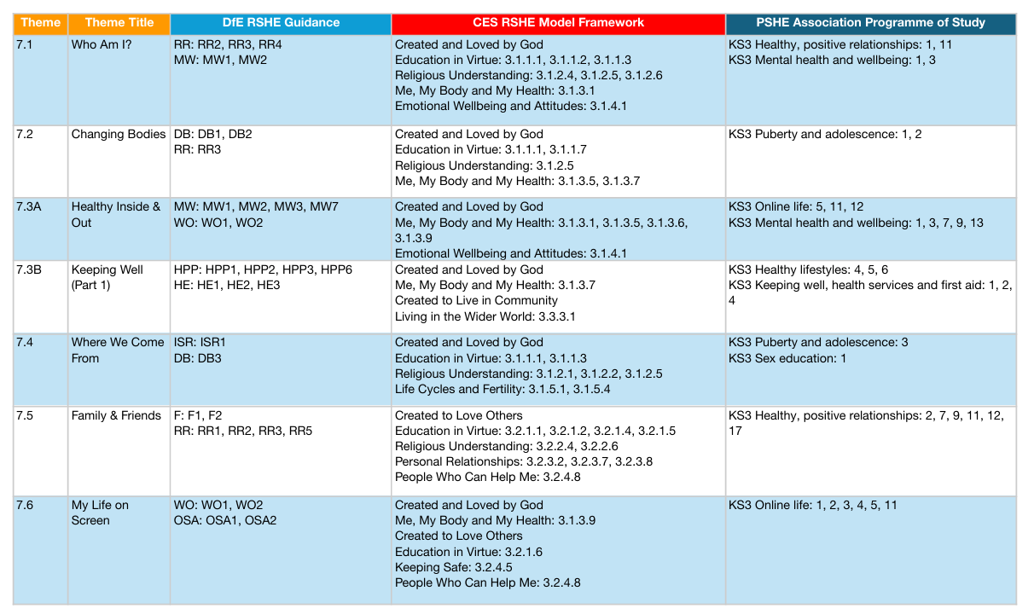

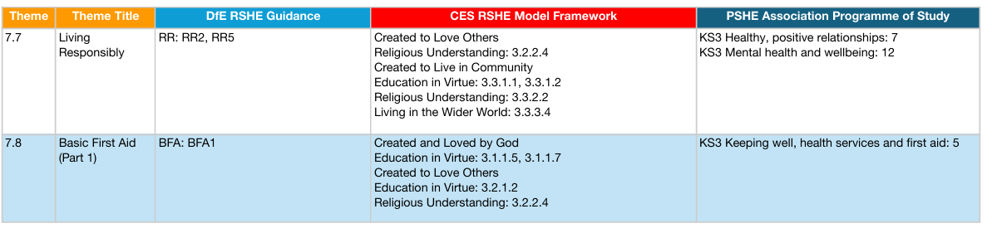

Topics also taught in Year 7 include
- Knife crime
- The Dangers of Drugs
- The Dangers of Alcohol
- Grooming- Recognising the Signs of Grooming
- Impact of Peer Pressure
- Personal Safety including water, road and railway
- Combatting prejudice
- Appreciating Diversity
- The Dangers of Vaping

Appendix 1: RSE Curriculum Year 8
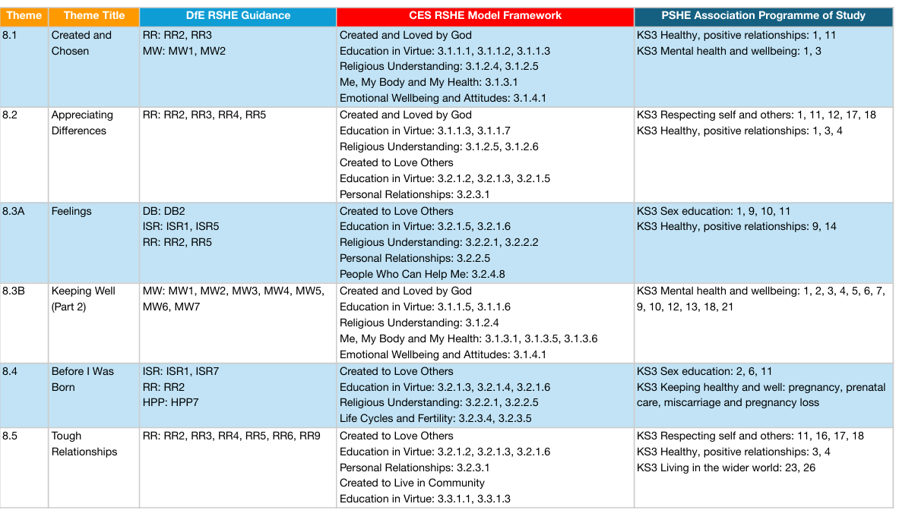
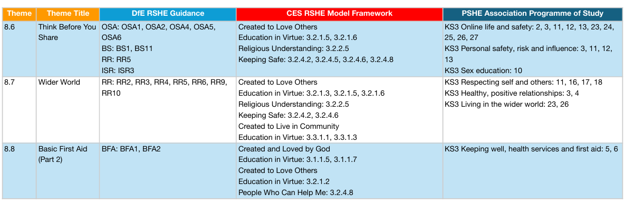
Topics also taught in Year 8 include
- Understanding Protected Characteristics
- Combatting Racism
- Prevent- Radicalisation
- Body Image
- Sexting and Appropiate Online Behaviour
- Dangers of Vaping
- Female Genital Mutilation
- County Lines
- Financial Literacy
- Personal Safety- Including road, water and rail safety

Appendix 1: RSE Curriculum Year 9
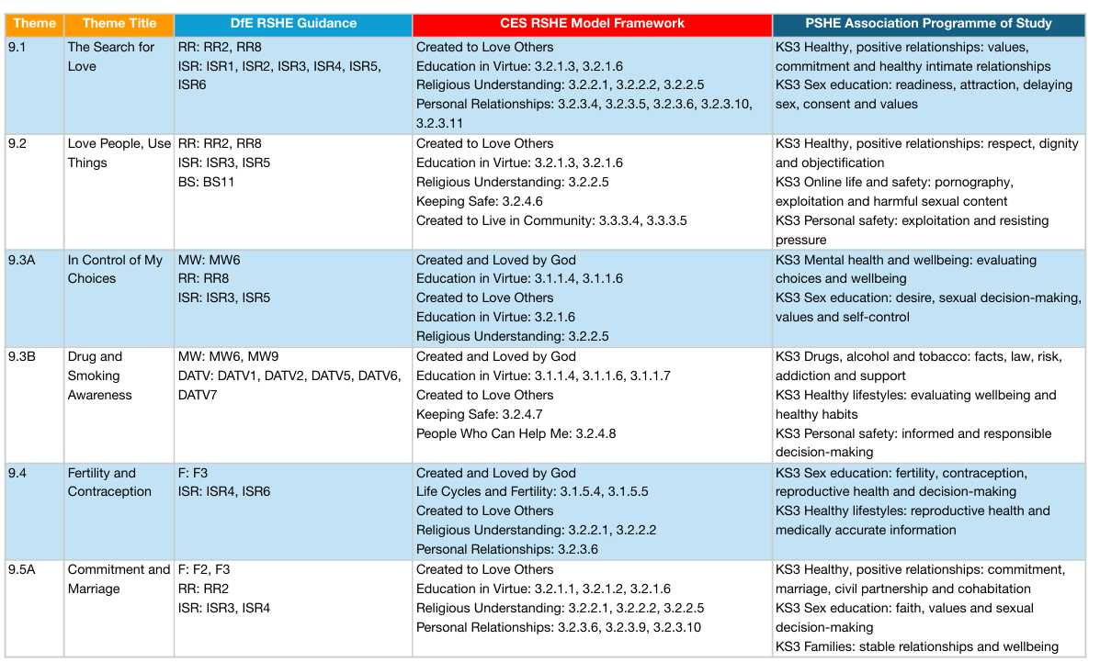
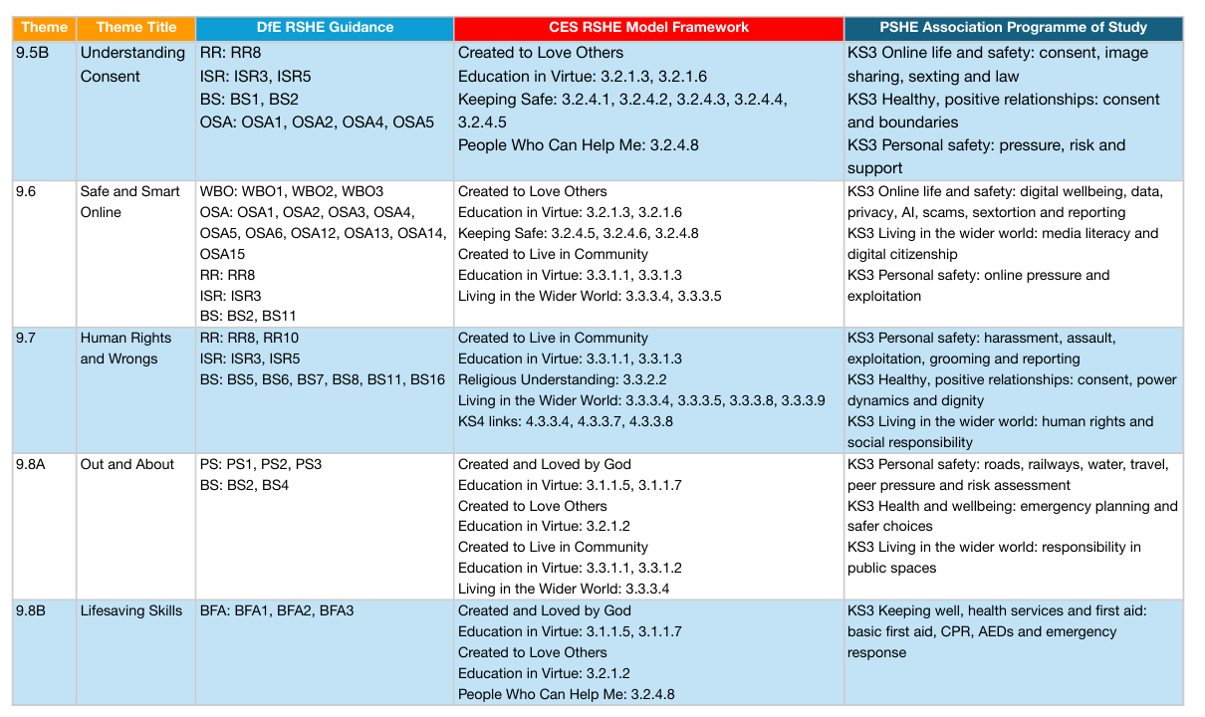
Topics also taught in Year 9 include
- Mysogny- What is it?
- Mysogny- How to combat it
- Phobic Bullying
- Sexual Harrasment and Stalking
- Knife Crime
- Gangs and Radicalisation
- The Dangers of Vaping
- Child Criminal Exploitation (CCE)
- Self Esteem
- County Lines
- Mental Health First Aid

Appendix 1: RSE Curriculum Year 10
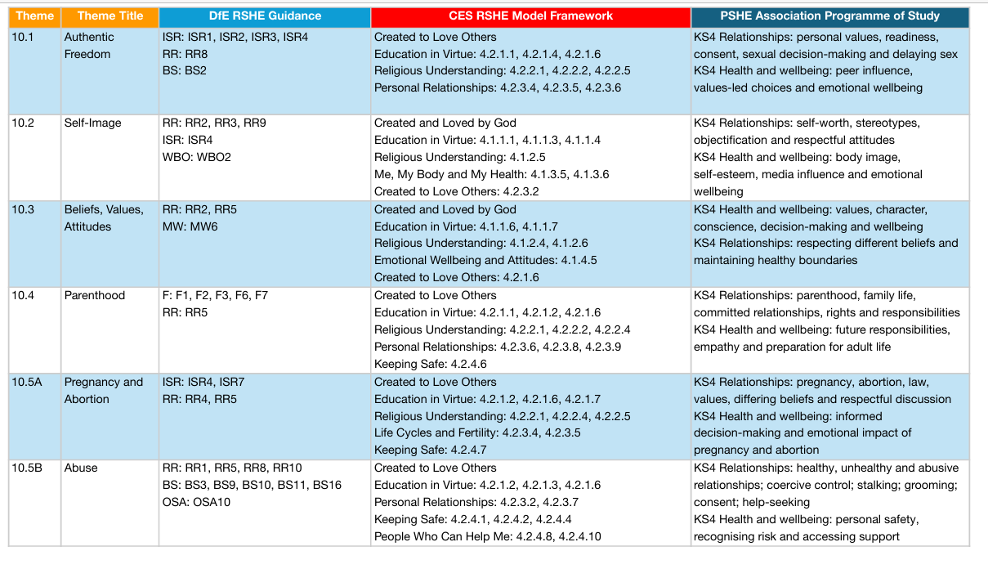
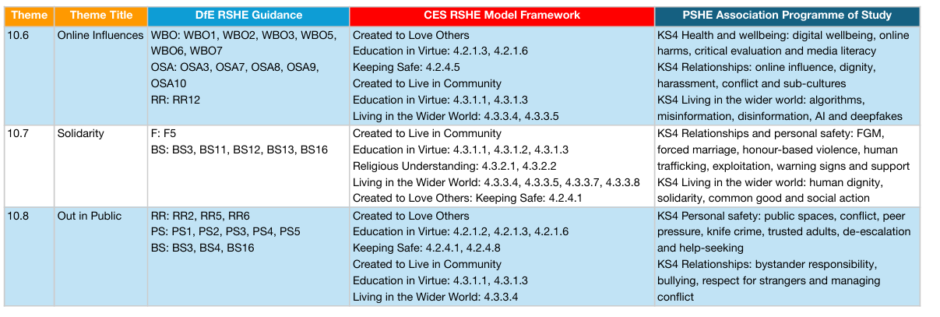
Topics also taught in Year 10 include
- Understanding Human Rights
- Honour Based Violence
- Forced Marriage
- Modern Day Slavery
- Financial Literacy
- The Dangers of Smoking and Vaping
- Domestic Abuse
- Radicalisation
- Mysogny
- Drugs, violence and gangs
- Online Safety
- Personal Safety including road, rail and water

Appendix 1: RSE Curriculum Year 11

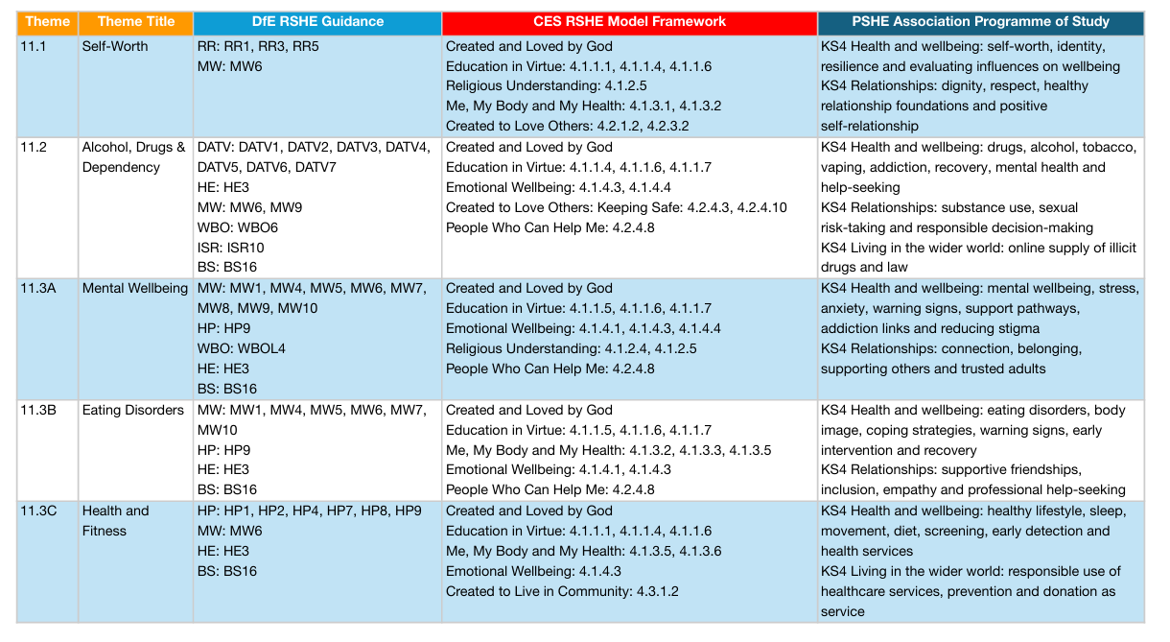
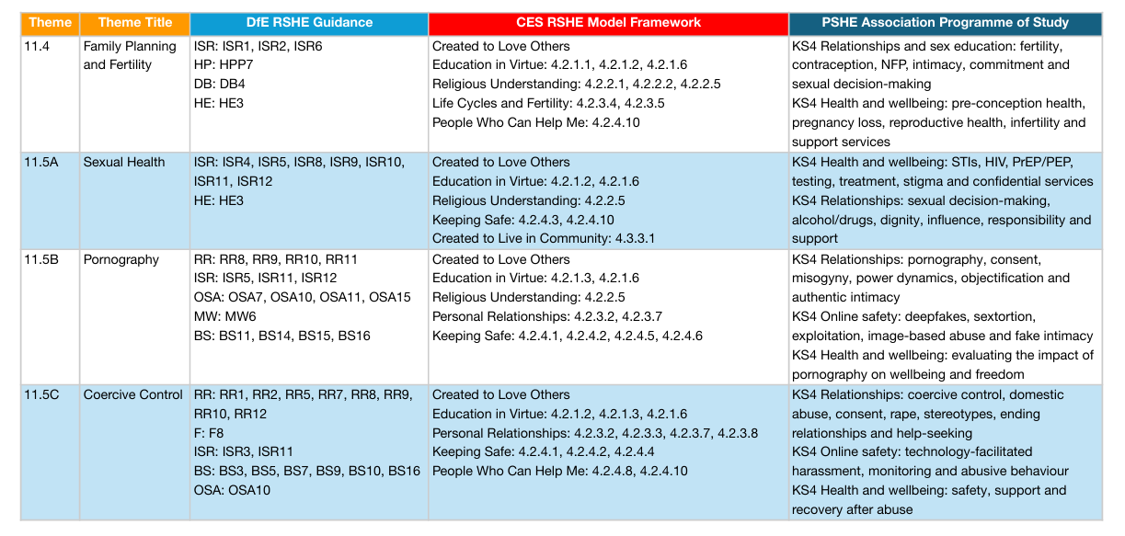

Appendix 2 Parent request for withdrawal from sex education
This form applies only to sex education delivered as part of RSE. It does not apply to relationships education, health education or science curriculum content.
Parent or carer information | Response
Name of pupil
Year and form
Name of parent or carer
Date
Sex education content from which withdrawal is requested
Reasons or information for the College to consider
Parent or carer signature

College record of discussion and decision
College record | Details
Date of discussion
People present
Curriculum and possible effects of withdrawal discussed
Decision and reasons
Purposeful alternative education arranged, if applicable
Pupil informed of the right to opt back in from three terms before age 16
Head of School signature and date

