

Malpractice Policy
Exams
2025/2026

This policy is reviewed annually to ensure compliance with current regulations

Approved/reviewed by
Stacy Jones
Date of next review | 12/09/2026

Key staff involved in the Malpractice Policy:

Role | Name(s)
Head of centre | Mrs Foster
Exams officer | Miss Jones
SLT member(s) | Mr Hambrook, Mr Jackson, Mr Baker
SENCO | Fiona Bansal

Introduction
What is malpractice and maladministration?
‘Malpractice’ and ‘maladministration’ are related concepts, the common theme of which is that they involve a failure to follow the rules of an examination or assessment. This policy and procedure use the word ‘malpractice’ to cover both ‘malpractice’ and ‘maladministration’ and it means any act, default or practice which is:
• a breach of the Regulations
• a breach of awarding body requirements regarding how a qualification should be delivered
• a failure to follow established procedures in relation to a qualification which:
o gives rise to prejudice to candidates
o compromises public confidence in qualifications
o compromises, attempts to compromise or may compromise the process of
assessment, the integrity of any qualification or the validity of a result or certificate
o damages the authority, reputation or credibility of any awarding body or centre or any officer, employee or agent of any awarding body or centre (SMPP 1)
Candidate malpractice
‘Candidate malpractice’ means malpractice by a candidate in connection with any examination or assessment, including the preparation and authentication of any controlled assessments, coursework or non-examination assessments, the presentation of any practical work, the compilation of portfolios of assessment evidence and the writing of any examination paper. (SMPP 2)
Centre staff malpractice
'Centre staff malpractice’ means malpractice committed by:
• a member of staff, contractor (whether employed under a contract of employment or a contract for services) or a volunteer at a centre; or
• an individual appointed in another capacity by a centre such as an invigilator, a Communication Professional, a Language Modifier, a practical assistant, a prompter, a reader or a scribe (SMPP 2)
Suspected malpractice
For the purposes of this document, suspected malpractice means all alleged or suspected incidents of malpractice. (SMPP 2)
Purpose of the policy
To confirm Bishop Milner Catholic College:
• has in place a written malpractice policy which covers all qualifications delivered by the centre and details how candidates are informed and advised to avoid committing malpractice in examinations/assessments, how suspected malpractice issues should be escalated within the centre and reported to the relevant awarding body (GR 5.3)
General principles
In accordance with the regulations, Bishop Miner Catholic College will:
• Take all reasonable steps to prevent the occurrence of any malpractice (which includes maladministration) before, during and after examinations have taken place (GR 5.11)
• Inform the awarding body immediately of any alleged, suspected or actual incidents of malpractice or maladministration involving a candidate or a member of staff by completing the appropriate documentation (GR 5.11)
• As required by an awarding body, gather evidence of any instances of alleged or suspected malpractice (which includes maladministration) in accordance with the JCQ publication Suspected Malpractice - Policies and Procedures and provide such information and advice as the awarding body may reasonably require (GR 5.11)
Preventing malpractice
Bishop Milner Catholic College has in place:
• Robust processes to prevent and identify malpractice, as outlined in section 3 of the JCQ publication Suspected Malpractice: Policies and Procedures. (SMPP 4.3)
• This includes ensuring that all staff involved in the delivery of assessments and examinations understand the requirements for conducting these as specified in the following JCQ documents and any further awarding body guidance:
o General Regulations for Approved Centres 2025-2026
o Instructions for conducting examinations (ICE) 2025-2026
o Instructions for conducting coursework 2025-2026
o Instructions for conducting non-examination assessments 2025-2026
o Access Arrangements and Reasonable Adjustments 2025-2026
o A guide to the special consideration process 2025-2026
o Suspected Malpractice: Policies and Procedures 2025-2026
Plagiarism in Assessments;
o AI Use in Assessments: Protecting the Integrity of Qualifications;
o A guide to the awarding bodies’ appeals processes 2025-2026 (SMPP 3.3.1)
Informing and advising candidates
During the autumn term, candidates will be supplied with an Exam Handbook (Summer 2026), which will inform and advise candidates to avoid committing malpractice in examinations/assessments. References to the use of AI will be included with information on how it will be treated as malpractice if AI is used inappropriately and without reference. Teachers will be signposted to the JCQ document 'Teachers & Assessors - AI Use in Assessments: Protecting the Integrity of Qualifications' so that they may brief candidates. Candidates will also be provided key information on avoiding malpractice during their mock examinations and in the relevant assemblies.
Identification and reporting of malpractice
Escalating suspected malpractice issues
• Once suspected malpractice is identified, any member of staff at the centre can report it using the appropriate channels (SMPP 4.3)
In the event of suspected malpractice, the member of staff will be able to report this to the Examinations Officer and Head of Centre.
Reporting suspected malpractice to the awarding body
• The head of the centre will notify the appropriate awarding body immediately of all alleged, suspected or actual incidents of malpractice, using the appropriate forms, and will conduct any investigation and gathering of information in accordance with the requirements of the JCQ publication Suspected Malpractice: Policies and Procedures (SMPP 4.1.3)
• The head of the centre will ensure that where a candidate who is a child/vulnerable adult is the subject of a malpractice investigation, the candidate’s parent/carer/ appropriate adult is kept informed of the progress of the investigation (SMPP 4.1.3)
• Form JCQ/M1 will be used to notify an awarding body of an incident of candidate malpractice. Form JCQ/M2 will be used to notify an awarding body of an incident of suspected staff malpractice/maladministration (SMPP 4.4, 4.6)
• Malpractice by a candidate discovered in a controlled assessment, coursework or non-examination assessment component prior to the candidate signing the declaration of authentication need not be reported to the awarding body but will be dealt with in accordance with the centre’s internal procedures. The only exception to this is where the awarding body’s confidential assessment material has potentially been breached. The breach will be reported to the awarding body immediately (SMPP 4.5)
• If, in the view of the investigator, there is sufficient evidence to implicate an individual in malpractice, that individual (a candidate or a member of staff) will be informed of the rights of accused individuals (SMPP 5.33)
• Once the information gathering has concluded, the head of the centre (or other appointed information-gatherer) will submit a written report summarising the information obtained and actions taken, including potential changes to assessment records, to the relevant awarding body, accompanied by the information obtained during the course of their enquiries (5.35)
• Form JCQ/M1 will be used when reporting candidate cases; for centre staff, form JCQ/M3 will be used (SMPP 5.37)
• The awarding body will decide, based on the report and any supporting documentation, whether there is evidence of malpractice and if any further investigation is required. The head of the centre will be informed accordingly (SMPP 5.40)
Communicating malpractice decisions
Once a decision has been made, it will be communicated in writing to the head of the centre as soon as possible. The head of the centre will communicate the decision to the individuals concerned and pass on details of any sanctions and action in cases where this is indicated. The head of the centre will also inform the individuals if they have the right to appeal. (SMPP 11.1)
Appeals against decisions made in cases of malpractice
Bishop Milner Catholic College will:
• Provide the individual with information on the process and timeframe for submitting an appeal, where relevant
• Refer to further information and follow the process provided in the JCQ publication A Guide to the Awarding Bodies' appeals processes.
Appendix 1
AI Malpractice
AI - Use in Assessments
AI use refers to the use of AI tools to obtain information and content which might be used in work produced for assessments which lead towards qualifications.
While the range of AI tools, and their capabilities, is likely to expand greatly in the near future, misuse of AI tools in relation to qualification assessments at any time constitutes malpractice. Teachers and students should also be aware that AI tools are still being developed and there are often limitations to their use, such as producing inaccurate or inappropriate content.
AI chatbots are AI tools which generate text in response to user prompts and questions. Users can ask follow-up questions or ask the chatbot to revise the responses already provided. AI chatbots respond to prompts based upon patterns in the data sets (large language model) upon which they have been trained. They generate responses which are statistically likely to be relevant and appropriate.
AI chatbots can complete tasks such as the following:
• Answering questions
• Analysing, improving, and summarising text
• Authoring essays, articles, fiction, and non-fiction
• Writing computer code • Translating text from one language to another
• Generating new ideas, prompts, or suggestions for a given topic or theme
• Generating text with specific attributes, such as tone, sentiment, or format
What is AI Misuse
AI misuse constitutes malpractice as defined in the JCQ Suspected Malpractice:
Policies and Procedures (https://www.jcq.org.uk/exams-office/malpractice/). The malpractice sanctions available for the offences of ‘making a false declaration of authenticity’ and ‘plagiarism’ include disqualification and debarment from taking qualifications for a number of years. Students’ marks may also be affected if they have relied on AI to complete an assessment and, as noted above, the attainment that they have demonstrated in relation to the requirements of the qualification does not accurately reflect their own work.
Examples of AI misuse include, but are not limited to, the following:
• Copying or paraphrasing sections of AI-generated content so that the work is no longer the student’s own
• Copying or paraphrasing whole responses of AI-generated content
• Using AI to complete parts of the assessment so that the work does not reflect the student’s own work, analysis, evaluation or calculations
• Failing to acknowledge use of AI tools when they have been used as a source of information
• Incomplete or poor acknowledgement of AI tools
• Submitting work with intentionally incomplete or misleading references or bibliographies.
Acknowledging AI Use
If a student uses an AI tool which provides details of the sources it has used in generating content, these sources must be verified by the student and referenced in their work in the normal way. Where an AI tool does not provide such details, students should ensure that they independently verify the AI-generated content – and then reference the sources they have used.
In addition to the above, where students use AI, they must acknowledge its use and show clearly how they have used it. This allows teachers and assessors to review how AI has been used and whether that use was appropriate in the context of the particular assessment. This is particularly important given that AI-generated content is not subject to the same academic scrutiny as other published sources.
Where AI tools have been used as a source of information, a student’s acknowledgement must show the name of the AI source used and should show the date the content was generated. For example: ChatGPT 3.5 (https://openai.com/ blog/ChatGPT/), 25/01/2024. The student must retain a copy of the question(s) and computer-generated content for reference and authentication purposes, in a non-editable format (such as a screenshot) and provide a brief explanation of how it has been used.
This must be submitted with the work so the teacher/assessor is able to review the work, the AI-generated content and how it has been used. Where this is not submitted, and the teacher/assessor suspects that the student has used AI tools, the teacher/assessor will need to consult the centre’s malpractice policy for appropriate next steps and should take action to assure themselves that the work is the student’s own
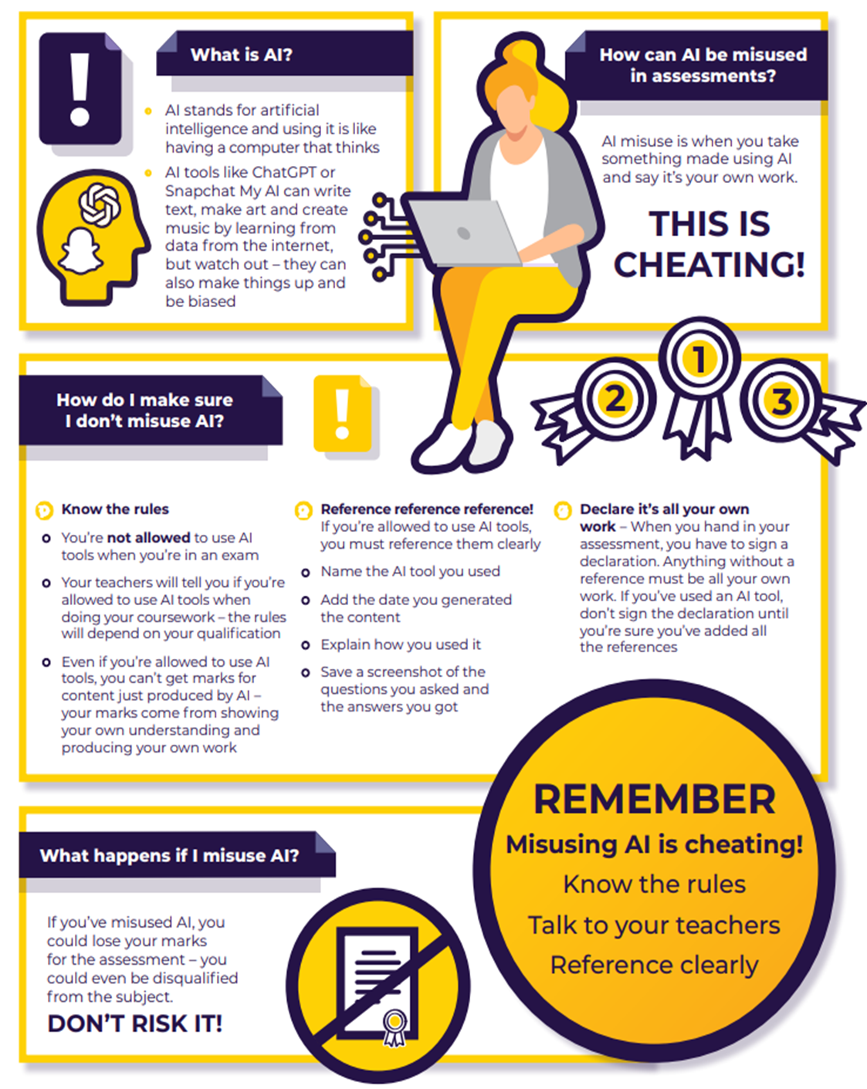
Appendix 2: AI Poster for students

Appendix 2 – Examples of Malpractice
The following are examples of malpractice. This is not an exhaustive list and as such does not limit the scope of the
definitions set out earlier in this document. Other instances of malpractice may be identified and considered by the
awarding bodies at their discretion.
Part 1: Centre staff malpractice
1. Breach of security
Any act which breaks the confidentiality of question papers or materials, and their electronic equivalents, or the confidentiality of candidates’ scripts or their electronic equivalents.
It could involve:
• failing to keep examination material secure prior to an examination, including digital examination materials;
• discussing or otherwise revealing information about examinations and assessments that should be kept confidential, e.g. internet forums/social media;
• moving the time or date of a fixed examination beyond the arrangements permitted within the JCQ document Instructions for conducting examinations. Conducting an examination before the published date constitutes centre staff malpractice and is a clear breach of security;
• failing to adequately supervise candidates who have been affected by a timetable variation (this would apply to candidates subject to overnight supervision by centre personnel or where an examination is to be sat in an earlier or later session on the scheduled day);
• releasing candidates early from a timetabled assessment (e.g. before 10 am for a morning session examination);
• permitting, facilitating or obtaining unauthorised access to examination material prior to an examination; • failing to retain and secure examination question papers after an examination in cases where the life of the paper extends beyond the particular session, e.g. where an examination is to be sat in a later session by one or more candidates due to a timetable variation;
• tampering with candidate scripts, controlled assessments, coursework or non-examination assessments after collection and before despatch to the awarding body/examiner/ moderator (this would additionally include reading candidates’ scripts or photocopying candidates’ scripts prior to despatch to the awarding body/examiner);
• failing to keep secure computer files which contain candidates’-controlled assessments, coursework or nonexamination assessments.
2. Deception
Any act of dishonesty in relation to an examination or assessment including, but not limited to:
• inventing or changing marks for internally assessed components (e.g. non-examination assessments) where there is no actual evidence of the candidates’ achievement to justify the marks awarded;
• manufacturing evidence of competence against national standards;
• fabricating assessment and/or internal verification records or authentication statements;
• entering fictitious candidates for examinations or assessments, or otherwise subverting the assessment or certification process with the intention of financial gain (fraud);
• substituting one candidate’s-controlled assessment, coursework or non-examination assessment for another’s;
• providing misleading or inaccurate information to an awarding body, candidates and/or parents.
3. Improper assistance to candidates
Any act where assistance is given beyond that permitted by the specification or regulations to a candidate or group of candidates, which results in a potential or actual advantage in an examination or assessment.
For example:
• assisting candidates in the production of controlled assessment, coursework, non-examination assessments or portfolios, beyond that permitted by the regulations;
• sharing or lending candidates’-controlled assessments, coursework or non-examination assessments with other candidates in a way which allows malpractice to take place;
• assisting or prompting candidates with the production of answers;
• permitting candidates in an examination to access prohibited materials (dictionaries, calculators etc.);
• prompting candidates in an examination/assessment by means of signs, or verbal or written prompts;
• assisting candidates granted the use of a Communication Professional, a Language Modifier, a practical assistant, a prompter, a reader or a scribe beyond that permitted by the regulations.
4. Failure to co-operate with an investigation
• failure to make available information reasonably requested by an awarding body in the course of an investigation, or in the course of deciding whether an investigation is necessary; and/or
• failure to investigate on request in accordance with the awarding body’s instructions or advice; and/or
• failure to investigate or provide information according to agreed deadlines; and/or
• failure to immediately report all alleged, suspected or actual incidents of malpractice to the awarding body.
5. Maladministration
Failure to adhere to the regulations regarding the conduct of controlled assessments, coursework, examinations and non-examination assessments, or malpractice in the conduct of examinations/assessments and/or the handling of examination question papers, candidate scripts, mark sheets, cumulative assessment records, results and certificate claim forms, etc.
For example:
• failing to ensure that candidates’-controlled assessment, coursework, non-examination assessment or work to be completed under controlled conditions is adequately completed and/or monitored and/or supervised;
• failure, on the part of the head of centre, to adhere to awarding body specification requirements in the delivery of non-examination assessments, Endorsements and other projects required as part of a qualification. These include the GCSE Computer Science Programming Project, GCSE English Language Spoken Language Endorsement and/or the GCE A-level Biology, Chemistry, Geology and Physics Practical Skills Endorsement;
• failing to adhere to awarding body key dates and deadlines relating to the delivery of examinations and assessments (such as those relating to the return of scripts, reporting of internal assessment marks/grades, making entries/claims, and Head of Centre declarations);
• inappropriate members of staff assessing candidates for access arrangements who do not meet the criteria as detailed within Chapter 7 of the JCQ document Access Arrangements and Reasonable Adjustments;
• failure to use the correct tasks/assignments for assessments;
• failure to train invigilators and those facilitating access arrangements adequately, e.g. readers and scribes, leading to non-compliance with the JCQ documents;
• failing to issue to candidates the appropriate notices and warnings, e.g. JCQ Information for candidate’s documents;
• failure to inform the JCQ Centre Inspection Service of alternative sites for examinations;
• failing to post notices relating to the examination or assessment outside all rooms (including Music and Art rooms) where examinations and assessments are held;
• not ensuring that the examination venue conforms to the requirements as stipulated in the JCQ document Instructions for conducting examinations;
• failing to prevent the introduction of unauthorised material into the examination room, either prior to or during the examination (NB this precludes the use of the examination room to coach candidates or give subject-specific presentations, including power-point presentations, prior to the start of the examination);
• failing to remind candidates that any mobile phones or other unauthorised items found in their possession must be handed to the invigilator prior to the examination starting;
• failure to invigilate examinations in accordance with the JCQ document Instructions for conducting examinations;
• failure to have on file for inspection purposes accurate records relating to overnight supervision arrangements;
• failure to have in place a malpractice policy;
• failure to have on file for inspection purposes appropriate evidence, as per the JCQ document Access Arrangements and Reasonable Adjustments, to substantiate approved access arrangements processed electronically using the Access arrangements online system;
• granting access arrangements to candidates who do not meet the requirements of the JCQ document Access Arrangements and Reasonable Adjustments;
• granting access arrangements to candidates where prior approval has not been obtained from the Access
arrangements online system or, in the case of a more complex arrangement, from an awarding body;
• failure to supervise effectively the printing of computer-based assignments when this is required;
• failing to retain candidates’-controlled assessments, coursework or non-examination assessments securely after the authentication statements have been signed or the work has been marked;
• failing to maintain the security of candidate scripts prior to despatch to the awarding body or examiner;
• failing to despatch candidates’ scripts, controlled assessments, coursework or non-examination assessments to the awarding bodies, examiners or moderators in a timely way;
• failing to notify the appropriate awarding body immediately of all alleged, suspected or actual incidents of malpractice;
• failing to conduct a thorough investigation into suspected examination or assessment malpractice when asked to do so by an awarding body;
• breaching the published arrangements for the release of examination results;
• inappropriate retention or destruction of certificates;
• failing to recruit learners with integrity, including the recruitment of learners who have not met the qualification’s minimum entry requirements wherever stipulated and/or the recruitment of learners who are unable or otherwise unlikely to complete the qualification.
• failing to ensure that, where candidates are producing work for assessments which are not completed under examination conditions, teaching staff check that the assessment tasks being completed and the approach candidates are taking are appropriate, giving due consideration to ethical standards and the centre’s safeguarding responsibilities.
Part 2: Candidate malpractice
For example:
• the alteration or falsification of any results document, including certificates;
• a breach of the instructions or advice of an invigilator, supervisor, or the awarding body in relation to the examination or assessment rules and regulations;42
• the unauthorised use of alternative electronic devices or technology during remote assessment and remote invigilation;
• accessing the internet, online materials or AI tools during remote assessment and remote invigilation, where this is not permitted;
• failing to abide by the conditions of supervision designed to maintain the security of the examinations or assessments;
• collusion: working collaboratively with others, beyond what is permitted;
• copying from another candidate (including the use of technology to aid the copying);
• allowing work to be copied, e.g. posting work on social networking sites prior to an examination/assessment;
• the deliberate destruction of another candidate’s work;
• disruptive behaviour in the examination room or during an assessment session (including the use of offensive language);
• failing to report to the centre or awarding body the candidate having unauthorised access to assessment related information or sharing unauthorised assessment related information online;
• exchanging, obtaining, receiving, passing on information (or the attempt to) which could be assessment related by means of talking, electronic, written or non-verbal communication;
• making a false declaration of authenticity in relation to the authorship of controlled assessment, coursework, non-examination assessment or the contents of a portfolio;
• allowing others to assist in the production of controlled assessments, coursework, non-examination assessments, examination responses or assisting others in the production of controlled assessments, coursework, non-examination assessments or examination responses;
• the misuse, or the attempted misuse, of examination and assessment materials and resources (e.g. exemplar materials);
• being in possession of unauthorised confidential information about an examination or assessment;
• bringing into the examination room notes in the wrong format (where notes are permitted in examinations) or inappropriately annotated texts (in open book examinations);
• the inclusion of offensive comments, obscenities or drawings; discriminatory language, remarks or drawings directed at an individual or group in scripts, controlled assessments, coursework, non-examination assessments or portfolios;
• personation: pretending to be someone else, arranging for another person to take one’s place in an examination or an assessment;
• plagiarism: unacknowledged copying from, or reproduction of, third party sources or incomplete referencing (including the internet and artificial intelligence (AI) tools);
• theft of another candidate’s work;
• being in possession (whether used or not) of unauthorised material during an examination or assessment, for example: notes, study guides and personal organisers, own blank paper, calculators (when prohibited), dictionaries (when prohibited), watches, instruments which can capture a digital image, electronic dictionaries (when prohibited), translators, wordlists, glossaries, iPods, mobile phones, Air Pods, MP3/4 players, pagers, or other similar electronic devices;
• the unauthorised use of a memory stick or similar device where a candidate uses a word processor;
• facilitating malpractice on the part of other candidates;
• behaving in a manner so as to undermine the integrity of the examination.

Further Information can be found on the school website: https://www.bmilner.dudley.sch.uk/examinformation
JCQ website:
www.jcq.org.uk/exams-office/ice---instructions-for-conducting-examinations
https://www.jcq.org.uk/wp-content/uploads/2025/04/AI-Use-in-Assessments_Apr25_FINAL.pdf

