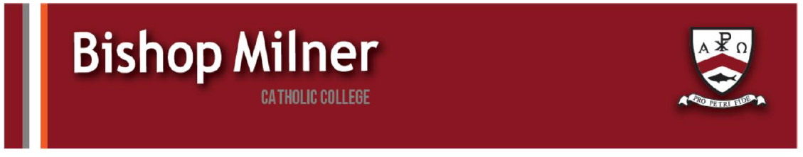
Careers support and information

Applications for the SMBP Work Insight and Skills Experience in West Midlands are open.
SMBP are hosting our Work Insight and Skills Experience in West Midlands in 2026. We would love to offer their opportunity to Year 12 and 13 students at your school / college. Please see the key details below:
West Midlands WISE Week: 20th – 24th July
What is SMBP WISE?
SMBP run WISE Weeks across the UK for eligible Year 12 and 13 students. These are 5 full days at 5 different high-profile workplaces in your area. They offer structured, skill-embedding Gatsby Benchmark-ed work experience for students from low-income backgrounds.
SMBP students:
Participate in a week-long work insight and skills experience in which they are given the opportunity to spend a day at four different businesses.
Attend a day run by a professional sports club to learn about the psychology of resilience and goal achievement models.
Have access to virtual Career Mentoring from legal, accountancy and business professionals. Our volunteers are on hand to help with creating Personal Statements/CVs, compiling application forms, and preparing for interviews.
Develop students’ key competency skills in the following areas: communication, teamwork and leadership, resilience and goal planning, creativity and problem solving.
Assist students with each step of their journey through virtual mentoring delivered through our own bespoke platform.
Next Steps:
I’ve attached the flyer with a QR Code linking to the website where students can find the application form.

PERFORMANCE THROUGH PEOPLE
Vacancies - Performance Through People
HALESOWEN COLLEGE
Final Open Event for this academic year will be on Wednesday 29th April 5pm – 7.30pm.
If your learners/parents wish to book a place to attend the Open Event they can click on the link below:
Halesowen College Open Events 2025/2026 Tickets, Multiple dates | Eventbrite
DATA INSPIRATION GROUP
Project Route is currently seeking enthusiastic and open-minded young people (aged 15–25) from across the UK to join our virtual Youth Advisory Group. The Group will bring together diverse voices to help shape the future of careers in the transport industry. It offers students a unique chance to develop new skills, build confidence, and collaborate with industry professionals while contributing their ideas to a real-world project. Importantly, students do not need any prior knowledge or experience in transport. We are keen to hear from those who are simply curious, willing to learn, and interested in exploring new opportunities.
The National Saturday Club
The National Saturday Club is an established UK-wide network, that gives 13—16-year-olds the unique opportunity to study subjects they love for FREE, on a Saturday at their local university, college or cultural institution. The Club provides a welcoming space for young people to build their skills, develop their confidence, and discover pathways to further study and future creative careers. With a particular focus on engaging young people from disadvantaged backgrounds and underrepresented communities the National Saturday Club’s established model has proven impact.

Applications are open to join the Science&Engineering Saturday Club at The Way Youth Zone, with University of Wolverhampton. The Club will run from 4th April to 11th June, 14.00-16.00. Club members also take part in national events including Masterclasses with leading industry professionals and the Summer Show, where Saturday Clubs nationwide exhibit their work in a public exhibition – all for free!
For more information and to apply to join the club please visit:
The Way Youth Zone and University of Wolverhampton - National Saturday Club

Calling all Year 10+ Students and Parents
Discover what a career at KPMG could look like at our Birmingham Careers & Community Evening.
📅 22nd April
⏰ 5:30PM – 7:00PM
📍 One Snowhill, Birmingham
Hear from current apprentices, explore career pathways, and get tips on standing out in applications.
👉 Book your place:
https://pathwayctm.com/event/inside-kpmg-birmingham-careers-community-evening/

